AP PRACTICE: UNIT 3 NAME: ____________________

2006 AP STATISTICS FREE-RESPONSE QUESTIONS
5) A biologist is interested in studying the effect of growth-enhancing nutrients and different salinity (salt) levels in water on the growth of shrimp. The biologist has ordered a large shipment of young tiger shrimps from a supply house to use for the study. The experiment is to be conducted in a lab where there are 12 tanks (with equal amount of shrimp in each) in a controlled environment. The biologist is planning to use 3 different growth-enhancing nutrients (A, B and C) and two different salinity levels (high and low).

- List the treatments that the biologist plans to use in this experiment (hint: there are 6!)
- Using the treatments listed in part (a), describe a completely randomized design that will allow the biologist to compare the shrimps growth after 3 weeks
- Give one statistical advantage of having only tiger shrimp in the experiment. Explain why this is an advantage.
- Give one statistical disadvantage of having only tiger shrimp in the experiment. Explain why this is an disadvantage.

2008 AP STATISTICS FREE-RESPONSE QUESTIONS (Form B)
4) A researcher wants to conduct a study to test whether listening to soothing music for 20 minutes helps to reduce diastolic blood pressure in patients with high blood pressure, compared to simply sitting quietly in a noise-free environment for 20 minutes. One hundred patients with high blood pressure at a large medical clinic are available to participate in this study.

- Propose a matched-pairs design for this study to compare these two treatments.
- Propose a completely randomized design for this study to compare these two treatments.

2007 AP STATISTICS FREE-RESPONSE QUESTIONS
2) As dogs age, diminished joint and hip health may lead to joint pain and thus reduce a dog’s activity level. Such a reduction in activity can lead to other health concerns. A study is to be conducted to see which of two dietary supplements, glucosamine or chondroitin, is more effective in promoting joint and hip health and reducing the onset of canine osteoarthritis. Researchers will randomly select a total of 300 dogs from ten different large veterinary practices around the country. All of the dogs are more than 6 years old and their owners have given consent to participate in the study. Changes in joint and hip health will be evaluated after 6 months of treatment.

- What would be an advantage of adding a control group to the design of the study?
- Assuming a control group is added, explain how you would assign the 300 dogs to the 3 treatment groups for a completely randomized design (do not draw the experiment!)
- Rather than using a completely randomized design, one group of researchers proposes blocking on clinics while another group of researchers proposes blocking on breed of dog. How would you decide which one of these two variables to use as a blocking variable?

2005 AP STATISTICS FREE-RESPONSE QUESTIONS
3) In search of a mosquito repellent that is safer than the ones that are currently on the market, scientists have developed a new compound that is rated as less toxic than the current compound thus making a repellant that contains this new compound safer for human use. Scientists also believe that a repellant containing the new compound will be more effective (at repelling mosquitoes) than the ones that contain the current compound. To test the effectiveness of the new compound versus the current compound, scientists have randomly selected 100 people from a state. Up to 100 bins, each with an equal number of mosquitoes in the bin, are available for use in this experiment. After a compound is applied to a participants forearm, the participant will insert his or her forearm into a bin for 1 minute, and the number of mosquito bites on the arm at the end of the minute will be recorded.

- Design this experiment using a completely randomized design.
- Design this experiment using a matched pairs design.
- Which of the two designs (in part A or part B) is better for testing the effectiveness of the new compound versus the current compound. Justify your answer.

2002 AP STATISTICS FREE-RESPONSE QUESTIONS
2) A manufacturer of boots plans to conduct an experiment to compare a new method of waterproofing to the current method. The appearance of the boots is not changed by either method. The company recruits 100 volunteers in Seattle where it rains frequently, to wear the boots as they normally would for 6 months. At the end of the 6 months, the boots will be returned to the company and evaluated for water damage.

- Describe a design for this experiment that uses the 100 volunteers. Include a few sentences on how it would be implemented (hint: the best design here is a matched pairs design)
- Could your experiment be double blind? Explain.

2008 AP STATISTICS FREE-RESPONSE QUESTIONS (Form B)
2) Four different statistics have been proposed as estimators of a population parameter. To investigate the behavior of these estimators, 500 random samples are selected from a known population and each statistic is calculated for each sample. The true value of the population parameter is 75. The graphs below show the distributions of values for each statistic.
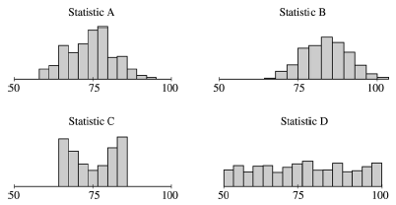
- Which of the statistics appear to be unbiased estimators of the population parameter? How can you tell?
- Which of statistics A or B would be a better estimator of the population parameter? Explain.
- Which of statistics C or D would be a better estimator of the population parameter? Explain.
2007 AP STATISTICS FREE RESPONSE QUESTIONS (Form B)
3) The US Dept. of Energy is conducting an experiment to compare the heat gain in houses using two different types of windows, A and B. Six windows of each type are available for the experiment. The Dept. has constructed a house with twelve windows as show on the floor plan below.
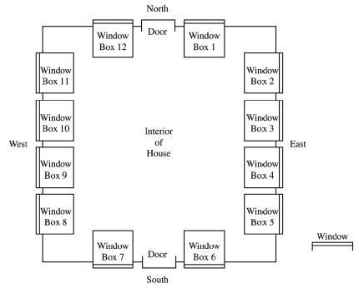
In the interior of the house, each window is surrounded by a window box to capture and measure the amount of heat coming in through that window and to isolate the heat gain for each window.

- A randomized block experiment will be used to compare the heat gain for the two types (A and B) of windows. How would you group the window boxes into blocks? (Clearly indicate your blocks using the window box numbers). Justify your choice of blocks.
- For the design in part (a), describe how you would assign window types (A and B) to the numbered window boxes.

AP Example Problem:
An experiment to determine the effect of a fertilizer on the growth of grass is to be conducted in a controlled environment. Identical soil and seeds are placed in plots in the lab. Once the grass starts growing, some plots are to be treated with the new fertilizer, while the rest receive no fertilizer. All other conditions regarding water, temperature, etc. are identical, except for the proximity of the plots to the single light source in the room. The figure below illustrates this. Create a block design experiment below. (remember, BLOCKS are groups of similar experimental units, where the similarity could have an effect on the experiment)
1
2
3
4
7
10
11
6
9
12
5
8

