Unit 2 Descriptive Statistics - Marks
1a. [1 mark]
Markscheme
(A1)(C1)
1b. [3 marks]
Markscheme
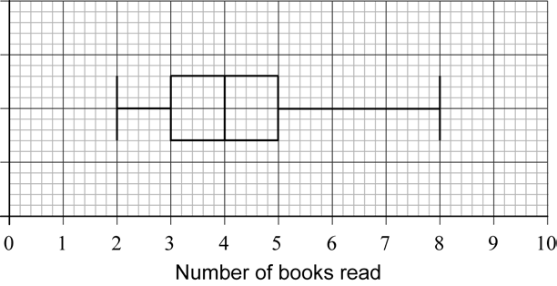 (A1)(ft)(A1)(A1) (C3)
Notes: Award (A1)(ft) for correct median, (A1) for correct quartiles and box, (A1) for endpoints 2 and 8 joined by a straight line that does not cross the box. Follow through from their median from part (a).
1c. [2 marks]
Markscheme
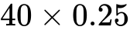 (M1)
Notes: Award (M1) for 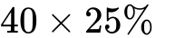OR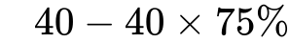.
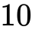 (A1) (C2)

2a. [3 marks]
Markscheme
(i) 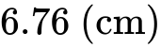 (G2)
Notes: Award (M1) for an attempt to use the formula for the mean with a least two rows from the table.
(ii) (G1)
2b. [3 marks]
Markscheme
(M1)(A1)
Notes: Award (M1) for attempting to use the normal distribution to find the probability or for correct region indicated on labelled diagram. Award (A1) for correct probability.
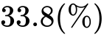 (A1)(ft)(G3)
Notes: Award (A1)(ft) for converting their probability into a percentage.
2c. [2 marks]
Markscheme
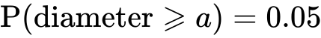 (M1)
Note: Award (M1) for attempting to use the normal distribution to find the probability or for correct region indicated on labelled diagram.
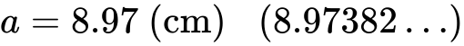 (A1)(G2)
2d. [2 marks]
Markscheme
(M1)
Note: Award (M1) for subtracting “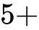 their part (b)” from 100 or (M1) for attempting to use the normal distribution to find the probability or for correct region indicated on labelled diagram.
(A1)(ft)(G2)
Notes:Follow through from their answer to part (b). Percentage symbol is not required. Accept 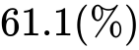(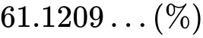) if 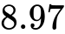used.
2e. [2 marks]
Markscheme
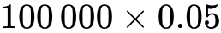 (M1)
Note: Award (M1) for multiplying by 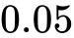 (or 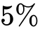).
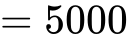 (A1)(G2)
3a. [1 mark]
Markscheme
discrete (A1) (C1)
3b. [2 marks]
Markscheme
(i) 60 (A1)
(ii) 5 (A1) (C2)
3c. [3 marks]
Markscheme
(i) 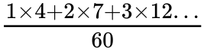 (M1)
Notes: Award (M1) for an attempt to substitute into the “mean of a set of data” formula, with at least three correct terms in the numerator.
Denominator must be 60.
Follow through from part (b)(i), only if work is seen.
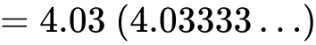 (A1)
Notes: Award at most (M1)(A0) for an answer of 4 but only if working seen.
(ii) 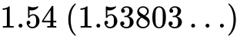 (A1) (C3)
4a. [2 marks]
Markscheme
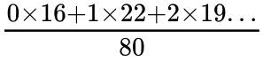 (M1)
Note: Award (M1) for substituting correct values into mean formula.
1.75 (A1) (C2)
[2 marks]
4b. [2 marks]
Markscheme
An attempt to enumerate the number of goals scored. (M1)
(A1) (C2)
[2 marks]
4c. [2 marks]
Markscheme
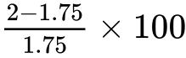 (M1)
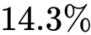 (A1)(ft) (C2)
Notes: Award (M1) for correctly substituted 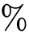 error formula. sign not required. Follow through from their answer to part (a). If 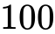 is missing and answer incorrect award (M0)(A0). If is missing and answer incorrectly rounded award (M1)(A1)(ft)(AP).
[2 marks]
5a. [2 marks]
Markscheme
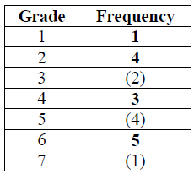 (A2) (C2)
Notes: Award (A1) for three correct. Award (A0) for two or fewer correct.
[2 marks]
5b. [1 mark]
Markscheme
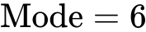 (A1)(ft) (C1)
[1 mark]
5c. [2 marks]
Markscheme
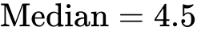 (M1)(A1)(ft) (C2)
Note: (M1) for attempt to order raw data (if frequency table not used) or (M1) halfway between 10th and 11th result.
[2 marks]
5d. [1 mark]
Markscheme
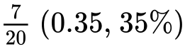 (A1)(ft) (C1)
[1 mark]
6a. [1 mark]
Markscheme
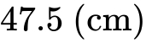 (A1)
6b. [4 marks]
Markscheme
(i) 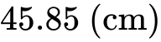 (G2)
Note: Accept 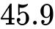 .
(ii) (G1)
(iii) (G1)
6c. [2 marks]
Markscheme
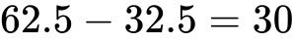 (M1)(A1)(G2)
Note: Award (M1) for correct quartiles seen.
6d. [4 marks]
Markscheme
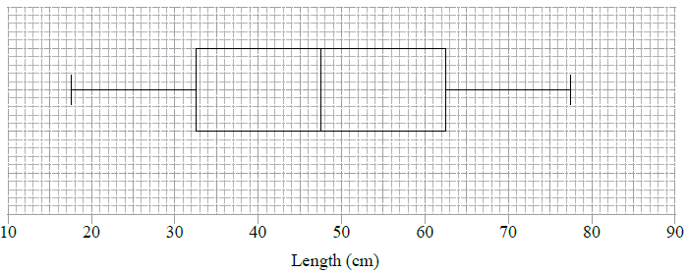
(A1) for correct label and scale
(A1)(ft) for correct median
(A1)(ft) for correct quartiles and box
(A1) for endpoints at 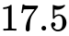 and 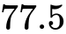 joined to box by straight lines (A1)(A1)(ft)(A1)(ft)(A1)
Notes: The final (A1) is lost if the lines go through the box. Follow through from their parts (b) and (c).
6e. [2 marks]
Markscheme
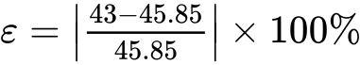 (M1)
Note: Award (M1) for their correct substitution in error formula.
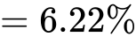 (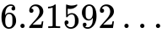) (A1)(ft)(G2)
Notes: Follow through from their answer to part (b)(i). Accept 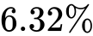 with use of .
7a. [2 marks]
Markscheme
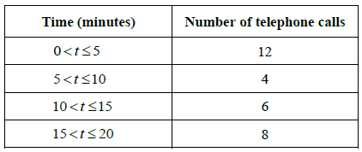 (A2) (C2)
Note: Award (A2) for four correct entries, (A1) for three correct entries, (A0) otherwise.
7b. [1 mark]
Markscheme
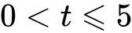 (A1) (C1)
7c. [1 mark]
Markscheme
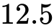 (A1) (C1)
7d. [2 marks]
Markscheme
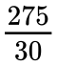 (M1)
Note: Award (M1) for division with 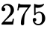 seen.
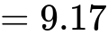 (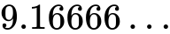) (A1)(ft) (C2)
Note: Follow through from their parts (a) and (c), irrespective of whether working is shown.
8a. [3 marks]
Markscheme
(i) 32.5 (A1)
(ii) 31.9 (A1)
(iii) 33.1 (A1) (C3)
Note: Answers must be given correct to 1 decimal place.
[3 marks]
8b. [3 marks]
Markscheme
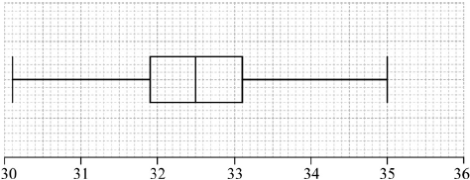
Note: Award (A1)(ft) for correct median, (A1)(ft) for correct quartiles and box, (A1) for correct end points of whiskers and straight whiskers.
Award at most (A1)(A1)(A0) if a horizontal line goes right through the box or if the whiskers are not well aligned with the midpoint of the box.
Follow through from part (a).
[3 marks]
9a. [3 marks]
Markscheme
(i) 300 (minutes) OR 5 hours (A1)
Note:If answer given in hours, the unit must be seen.
(ii) 220 – 100 (M1)
Notes: Award (M1) for the two quartiles seen.
= 120 (minutes) OR 2 hours (A1) (C3)
Note: If answer given in hours, the unit must be seen.
9b. [1 mark]
Markscheme
median (time spent on homework per day) (A1) (C1)
Note: Do not accept middle or medium etc.
9c. [2 marks]
Markscheme
(i) 25 (A1)
(ii) 75 (A1) (C2)
10a. [1 mark]
Markscheme
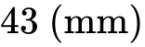 (A1) (C1)
[1 mark]
10b. [1 mark]
Markscheme
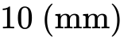 (A1) (C1)
[1 mark]
10c. [2 marks]
Markscheme
(A1)
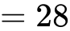 (A1) (C2)
Note: Award (A1) for identifying correct quartiles, (A1) for correct subtraction of the quartiles.
[2 marks]
10d. [2 marks]
Markscheme
(i) 20 (days) (A1)
(ii) 60 (days) (A1) (C2)
[2 marks]
11a. [1 mark]
Markscheme
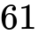 kg (A1) (C1)
[1 mark]
11b. [2 marks]
Markscheme
(A1)
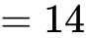 (A1)(ft) (C2)
Note: Award (A1) for identifying quartiles, (A1)(ft) for correct subtraction of their quartiles.
[2 marks]
11c. [1 mark]
Markscheme
(A1) (C1)
[1 marks]
11d. [2 marks]
Markscheme
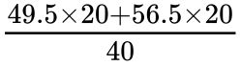 (M1)
Note: Award (M1) for multiplication of midpoints by frequencies.
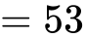 kg (A1) (C2)
[2 marks]
12a. [1 mark]
Markscheme
30 (A1) (C1)
[1 mark]
12b. [1 mark]
Markscheme
32 (A1) (C1)
[1 mark]
12c. [2 marks]
Markscheme
38 – 10 = 28 (A1)(A1) (C2)
Note: Award (A1) for 10 and 38 seen, (A1) for correct answer only.
[2 marks]
12d. [2 marks]
Markscheme
0.25 × 56 = 14 (M1)(A1) (C2)
Note: Award (M1) for multiplying 0.25 by 56.
[2 marks]
13a. [1 mark]
Markscheme
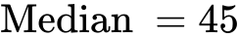 (A1) (C1)
Accept 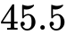
[1 mark]
13b. [2 marks]
Markscheme
for identifying correct quartiles (A1)
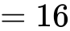 for correct answer to subtraction (A1)(ft) (C2)
(ft) on their quartiles
[2 marks]
13c. [3 marks]
Markscheme
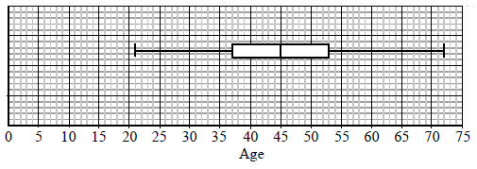
Median marked correctly. (A1)(ft)
Box with ends at candidate’s quartiles. (A1)(ft)
End points at 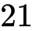 and 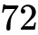 joined to box with straight lines. (A1) (C3)
Note: Award (A0) if lines go right through the box.
[3 marks]
14a. [1 mark]
Markscheme
48 (A1) (C1)
14b. [2 marks]
Markscheme
(M1)
Note: Award (M1) for 58 and 40 seen.
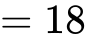 (A1) (C2)
14c. [3 marks]
Markscheme
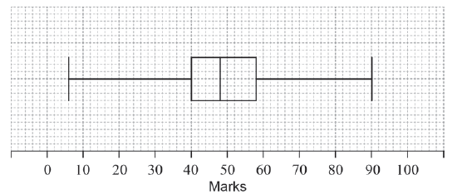
(A1)(A1)(ft)(A1)(ft) (C3)
Note: Award (A1) for the correct maximum and minimum, (A1)(ft) for their correct median and (A1)(ft) for 40 and their upper quartile.
Follow through from parts (a) and (b).
Award a maximum of (A1)(A1)(ft)(A0) if the horizontal line goes through the box or if a ruler has clearly not been used.
15a. [1 mark]
Markscheme
3 (A1) (C1)
[1 mark]
15b. [2 marks]
Markscheme
4 (M1)(A1) (C2)
Note: Award (M1) for ordered list of numbers seen.
[2 marks]
15c. [1 mark]
Markscheme
5.5 (A1) (C1)
[1 mark]
15d. [2 marks]
Markscheme
5.5 – 3 (M1)
Note: Award (M1) for 3 and their 5.5 seen.
= 2.5 (A1)(ft) (C2)
Note: Follow through from their answer to part (c).
[2 marks]
16a. [1 mark]
Markscheme
(A1) (C1)
[1 mark]
16b. [2 marks]
Markscheme
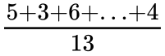 (M1)
Note: Award (M1)for correctly substituted mean formula, division by 13 must be seen.
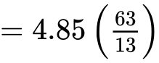 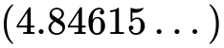(A1) (C2)
[2 marks]
16c. [1 mark]
Markscheme
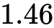 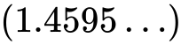 (A1) (C1)
[1 mark]
16d. [2 marks]
Markscheme
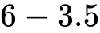 (M1)
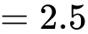 (A1) (C2)
Note: Award (M1) for their quartiles seen or a correct ordered list. Accept a correct ordered list from any previous part of the question.
[2 marks]
17a. [2 marks]
Markscheme
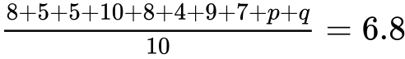 or equivalent (M1)(A1) (C2)
Note: Award (M1) for correct substituted mean formula, (A1) for correct substitution.
[2 marks]
17b. [1 mark]
Markscheme
p = 5 (A1)(ft)
[1 mark]
17c. [1 mark]
Markscheme
q = 7 (A1)(ft) (C2)
Note: Follow through from their answers to parts (a) and (b) (i).
[1 mark]
17d. [2 marks]
Markscheme
7 (M1)(A1)(ft) (C2)
Notes: Award (M1) for an attempt to order their numbers.
Follow through from their answers to parts (b)(i) and (ii).
[2 marks]
18a. [3 marks]
Markscheme
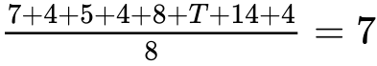 (A1)(A1)
Note: Award (A1) for sum + T, (A1) for 56 or 7 × 8 or 8 in the denominator and 7 seen.
T = 10 (A1) (C3)
[3 marks]
18b. [1 mark]
Markscheme
4 (A1) (C1)
[1 mark]
18c. [2 marks]
Markscheme
4, 4, 4, 5, 7, 8, 10, 14 (M1)
Note: Award (M1) for arranging their numbers in order.
Median = 6 (A1)(ft) (C2)
[2 marks]

Printed for William Howard Taft High School
© International Baccalaureate Organization 2018
International Baccalaureate® - Baccalauréat International® - Bachillerato Internacional®

