Unit 2 Review – Descriptive Statistics
1a. [1 mark]
Two groups of 40 students were asked how many books they have read in the last two months. The results for the first group are shown in the following table.
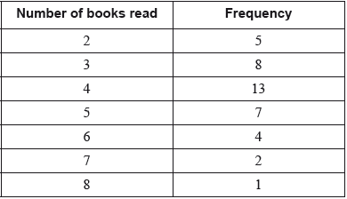
The quartiles for these results are 3 and 5.
Write down the value of the median for these results.
1b. [3 marks]
Draw a box-and-whisker diagram for these results on the following grid.
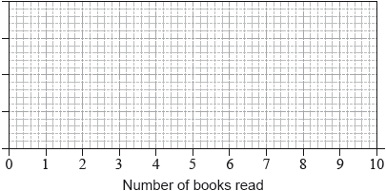
1c. [2 marks]
The results for the second group of 40 students are shown in the following box-and-whisker diagram.
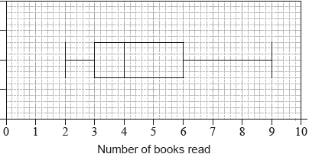
Estimate the number of students in the second group who have read at least 6 books.
2a. [3 marks]
Daniel grows apples and chooses at random a sample of 100 apples from his harvest.
He measures the diameters of the apples to the nearest cm. The following table shows the distribution of the diameters.
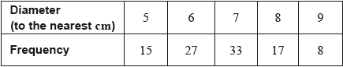
Using your graphic display calculator, write down the value of
(i) the mean of the diameters in this sample;
(ii) the standard deviation of the diameters in this sample.
2b. [3 marks]
Daniel assumes that the diameters of all of the apples from his harvest are normally distributed with a mean of 7 cm and a standard deviation of 1.2 cm. He classifies the apples according to their diameters as shown in the following table.
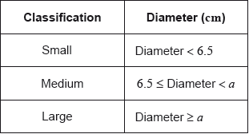
Calculate the percentage of small apples in Daniel’s harvest.
2c. [2 marks]
Daniel assumes that the diameters of all of the apples from his harvest are normally distributed with a mean of 7 cm and a standard deviation of 1.2 cm. He classifies the apples according to their diameters as shown in the following table.
Of the apples harvested, 5% are large apples.
Find the value of .
2d. [2 marks]
Daniel assumes that the diameters of all of the apples from his harvest are normally distributed with a mean of 7 cm and a standard deviation of 1.2 cm. He classifies the apples according to their diameters as shown in the following table.
Find the percentage of medium apples.
2e. [2 marks]
Daniel assumes that the diameters of all of the apples from his harvest are normally distributed with a mean of 7 cm and a standard deviation of 1.2 cm. He classifies the apples according to their diameters as shown in the following table.
This year, Daniel estimates that he will grow apples.
Estimate the number of large apples that Daniel will grow this year.
3a. [1 mark]
In a particular week, the number of eggs laid by each hen on a farm was counted. The results are summarized in the following table.
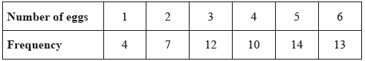
State whether these data are discrete or continuous.
3b. [2 marks]
Write down
(i) the number of hens on the farm;
(ii) the modal number of eggs laid.
3c. [3 marks]
Calculate
(i) the mean number of eggs laid;
(ii) the standard deviation.
4a. [2 marks]
matches were played in a football tournament. The following table shows the number of goals scored in all matches.
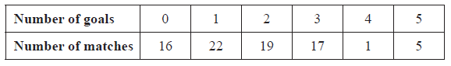
Find the mean number of goals scored per match.
4b. [2 marks]
Find the median number of goals scored per match.
4c. [2 marks]
A local newspaper claims that the mean number of goals scored per match is two. Calculate the percentage error in the local newspaper’s claim.
5a. [2 marks]
The grades obtained by a group of IB students are listed below:
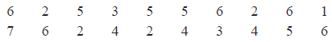
Complete the following table for the grades obtained by the students.
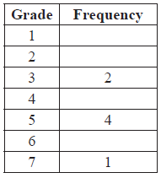
5b. [1 mark]
Write down the modal grade obtained by the students.
5c. [2 marks]
Calculate the median grade obtained by the students.
5d. [1 mark]
One student is chosen at random from the group.
Find the probability that this student obtained either grade or grade .
6a. [1 mark]
The lengths () in centimetres of 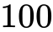 copper pipes at a local building supplier were measured. The results are listed in the table below.
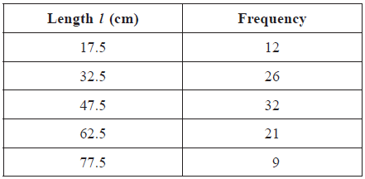
Write down the mode.
6b. [4 marks]
Using your graphic display calculator, write down the value of
(i) the mean;
(ii) the standard deviation;
(iii) the median.
6c. [2 marks]
Find the interquartile range.
6d. [4 marks]
Draw a box and whisker diagram for this data, on graph paper, using a scale of 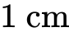 to represent 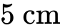.
6e. [2 marks]
Sam estimated the value of the mean of the measured lengths to be 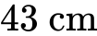.
Find the percentage error of Sam’s estimated mean.
7a. [2 marks]
Consider the frequency histogram for the distribution of the time, , in minutes of telephone calls that Helen made last week.
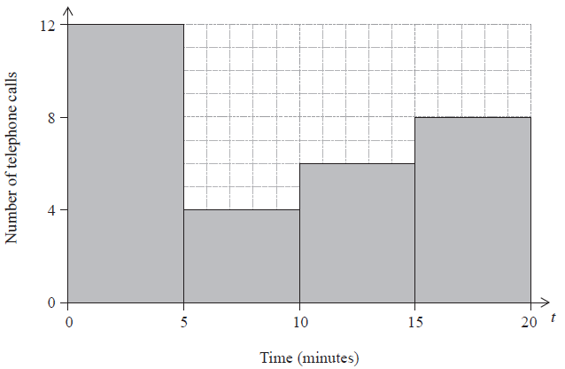
Complete the frequency table for this distribution.
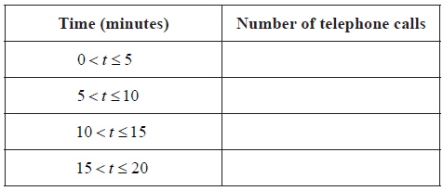
7b. [1 mark]
Write down the modal class.
7c. [1 mark]
Write down the mid interval value of the 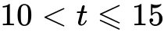 class.
7d. [2 marks]
Use your graphic display calculator to find an estimate for the mean time.
8a. [3 marks]
A sample of 120 oranges was tested for Vitamin C content. The cumulative frequency curve below represents the Vitamin C content, in milligrams, of these oranges.
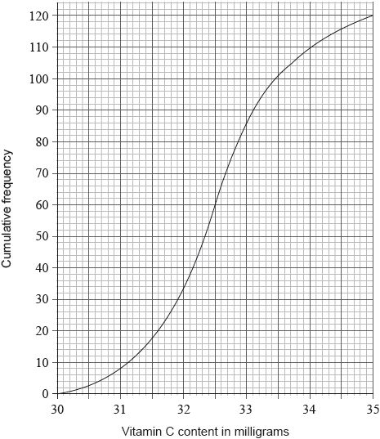
Giving your answer to one decimal place, write down the value of
(i) the median level of Vitamin C content of the oranges in the sample;
(ii) the lower quartile;
(iii) the upper quartile.
8b. [3 marks]
The minimum level of Vitamin C content of an orange in the sample was 30.1 milligrams. The maximum level of Vitamin C content of an orange in the sample was 35.0 milligrams.
Draw a box-and-whisker diagram on the grid below to represent the Vitamin C content, in milligrams, for this sample.
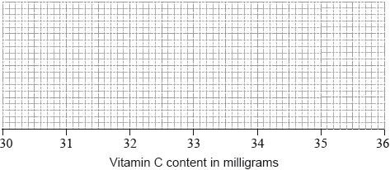
9a. [3 marks]
The time, in minutes, that students in a school spend on their homework per day is presented in the following box-and-whisker diagram.
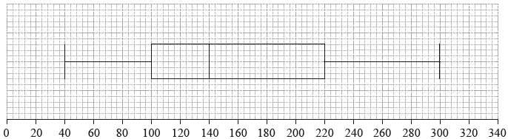
Time, in minutes, students spend on their homework per day
Find
(i) the longest amount of time spent on homework per day;
(ii) the interquartile range.
9b. [1 mark]
State the statistical term corresponding to the value of 140 minutes.
9c. [2 marks]
Find the percentage of students who spend
(i) between 100 and 140 minutes per day on their homework;
(ii) more than 100 minutes per day on their homework.
10a. [1 mark]
The distribution of rainfall in a town over 80 days is displayed on the following box-and-whisker diagram.
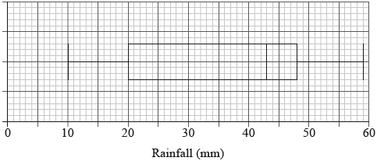
Write down the median rainfall.
10b. [1 mark]
Write down the minimum rainfall.
10c. [2 marks]
Find the interquartile range.
10d. [2 marks]
Write down the number of days the rainfall will be
(i) between 43 mm and 48 mm;
(ii) between 20 mm and 59 mm.
11a. [1 mark]
The weights in kg, of 80 adult males, were collected and are summarized in the box and whisker plot shown below.
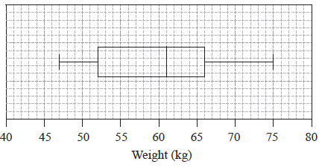
Write down the median weight of the males.
11b. [2 marks]
Calculate the interquartile range.
11c. [1 mark]
Estimate the number of males who weigh between 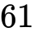 kg and 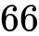 kg.
11d. [2 marks]
Estimate the mean weight of the lightest 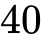 males.
12a. [1 mark]
56 students were given a test out of 40 marks. The teacher used the following box and whisker plot to represent the marks of the students.
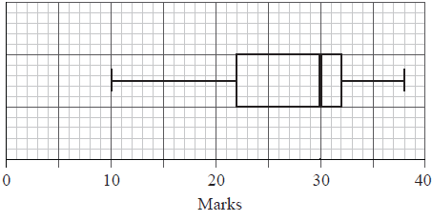
Write down the median mark.
12b. [1 mark]
Write down the 75th percentile mark.
12c. [2 marks]
Write down the range of marks.
12d. [2 marks]
Estimate the number of students who achieved a mark greater than 32.

Printed for William Howard Taft High School
© International Baccalaureate Organization 2018
International Baccalaureate® - Baccalauréat International® - Bachillerato Internacional®

