Solutions Unit 3 - Exponentials
1a. [2 marks]
The number of bacteria in two colonies, and , starts increasing at the same time.
The number of bacteria in colony after hours is modelled by the function 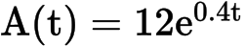.
Find the number of bacteria in colony initially.

Markscheme
correct substitution into formula (A1)
eg 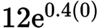
bacteria in the dish A1 N2
[2 marks]
1b. [3 marks]
Find the number of bacteria in colony after four hours.

Markscheme
correct substitution into formula (A1)
eg 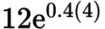
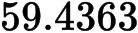 (A1)
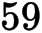 bacteria in the dish (integer answer only) A1 N3
[3 marks]
1c. [3 marks]
How long does it take for the number of bacteria in colony to reach ?

Markscheme
correct equation (A1)
eg 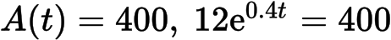
valid attempt to solve (M1)
eg graph, use of logs
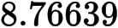
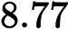 (hours) A1 N3
[3 marks]
1d. [3 marks]
The number of bacteria in colony after hours is modelled by the function 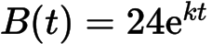.
After four hours, there are 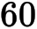 bacteria in colony . Find the value of .

Markscheme
valid attempt to solve (M1)
eg 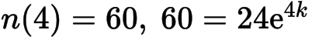, use of logs
correct working (A1)
eg sketch of intersection, 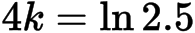
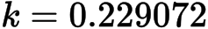
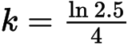 (exact), 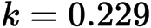 A1 N3
[3 marks]
1e. [4 marks]
The number of bacteria in colony after hours is modelled by the function .
The number of bacteria in colony first exceeds the number of bacteria in colony after hours, where 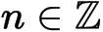. Find the value of .

Markscheme
METHOD 1
setting up an equation or inequality (accept any variable for ) (M1)
eg
correct working (A1)
eg sketch of intersection, 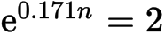
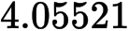 (accept 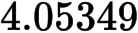) (A1)
(integer answer only) A1 N3
METHOD 2
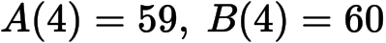 (from earlier work)
A1A1
valid reasoning (R1)
eg 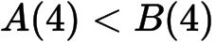 and 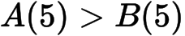
(integer answer only) A1 N3
[4 marks]
2a. [1 mark]
Let 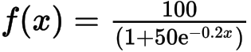 . Part of the graph of is shown below.
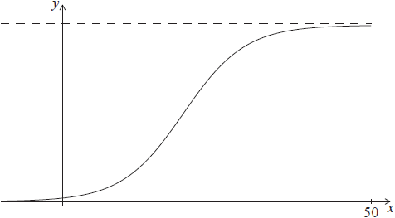
Write down 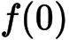 .

Markscheme
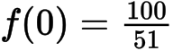 (exact), 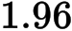 A1 N1
[1 mark]
2b. [2 marks]
Solve 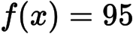 .

Markscheme
setting up equation (M1)
eg 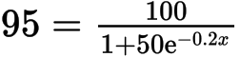 , sketch of graph with horizontal line at 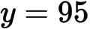
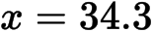 A1 N2
[2 marks]
2c. [3 marks]
Find the range of .

Markscheme
upper bound of is (A1)
lower bound of is (A1)
range is 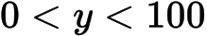 A1 N3
[3 marks]
3a. [1 mark]
Jose takes medication. After t minutes, the concentration of medication left in his bloodstream is given by 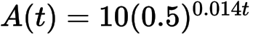 , where A is in milligrams per litre.
Write down 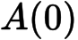 .

Markscheme
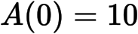 A1 N1
[1 mark]
3b. [2 marks]
Find the concentration of medication left in his bloodstream after 50 minutes.

Markscheme
substitution into formula (A1)
e.g. 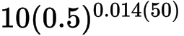 , 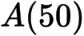
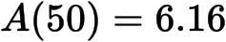 A1 N2
[2 marks]
3c. [5 marks]
At 13:00, when there is no medication in Jose’s bloodstream, he takes his first dose of medication. He can take his medication again when the concentration of medication reaches 0.395 milligrams per litre. What time will Jose be able to take his medication again?

Markscheme
set up equation (M1)
e.g. 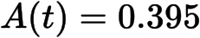
attempting to solve (M1)
e.g. graph, use of logs
correct working (A1)
e.g. sketch of intersection,
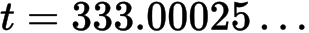 A1
correct time 18:33 or 18:34 (accept 6:33 or 6:34 but nothing else) A1 N3
[5 marks]
4. [3 marks]
Let 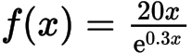 , for 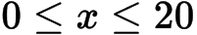 .
(i) Write down the x-coordinate of the maximum point on the graph of f .
(ii) Write down the interval where f is increasing.

Markscheme
(i) A1 N1
(ii) correct interval, with right end point 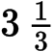 A1A1 N2
e.g. 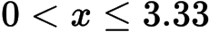 , 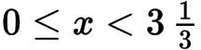
Note: Accept any inequalities in the right direction.
[3 marks]
5a. [2 marks]
Let 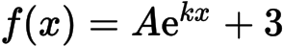 . Part of the graph of f is shown below.
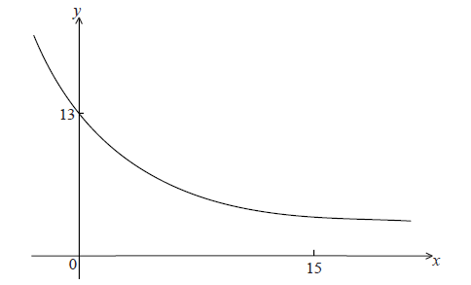
The y-intercept is at (0, 13) .
Show that .

Markscheme
substituting (0, 13) into function M1
e.g. 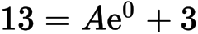
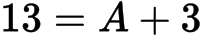 A1
AG N0
[2 marks]
6a. [3 marks]
Let f be the function given by 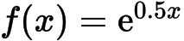 , 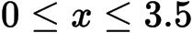 . The diagram shows the graph of f .
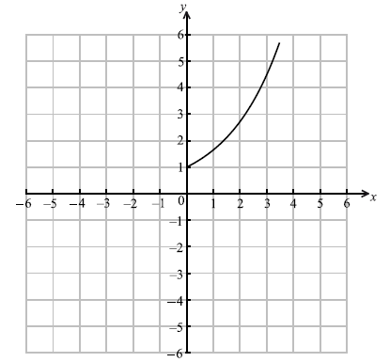
On the same diagram, sketch the graph of 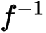 .

Markscheme
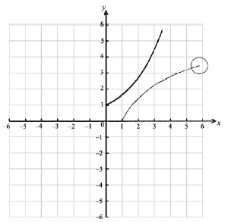 A1A1A1 N3
Note: Award A1 for approximately correct (reflected) shape, A1 for right end point in circle, A1 for through 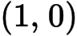 .
6b. [1 mark]
Write down the range of .

Markscheme
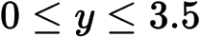 A1 N1
[1 mark]
6c. [3 marks]
Find 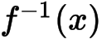 .

Markscheme
interchanging x and y (seen anywhere) M1
e.g. 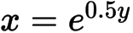
evidence of changing to log form A1
e.g. 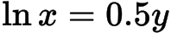 , 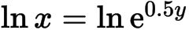 (any base), 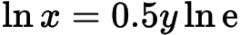 (any base)
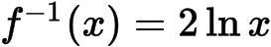 A1 N1
[3 marks]
8a. [3 marks]
Let 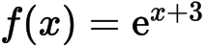 .
(i) Show that 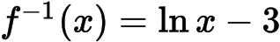 .
(ii) Write down the domain of .

Markscheme
(i) interchanging x and y (seen anywhere) M1
e.g. 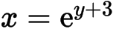
correct manipulation A1
e.g. 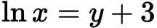 , 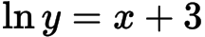
AG N0
(ii) 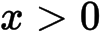 A1 N1
[3 marks]
9a. [2 marks]
The number of bacteria, n , in a dish, after t minutes is given by 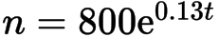 .
Find the value of n when .

Markscheme
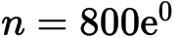 (A1)
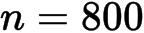 A1 N2
[2 marks]
11a. [6 marks]
A city is concerned about pollution, and decides to look at the number of people using taxis. At the end of the year 2000, there were 280 taxis in the city. After n years the number of taxis, T, in the city is given by
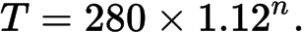
(i) Find the number of taxis in the city at the end of 2005.
(ii) Find the year in which the number of taxis is double the number of taxis there were at the end of 2000.

Markscheme
(i) (A1)
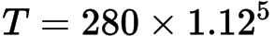
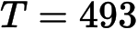 A1 N2
(ii) evidence of doubling (A1)
e.g. 560
setting up equation A1
e.g. 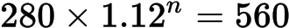, 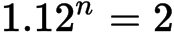
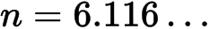 (A1)
in the year 2007 A1 N3
[6 marks]
11b. [6 marks]
At the end of 2000 there were 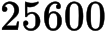 people in the city who used taxis.
After n years the number of people, P, in the city who used taxis is given by
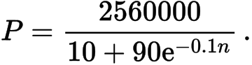
(i) Find the value of P at the end of 2005, giving your answer to the nearest whole number.
(ii) After seven complete years, will the value of P be double its value at the end of 2000? Justify your answer.

Markscheme
(i) 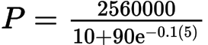 (A1)
(A1)
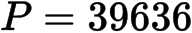 A1 N3
(ii) 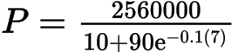
A1
not doubled A1 N0
valid reason for their answer R1
e.g.
[6 marks]
12a. [3 marks]
Let 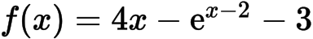 , for 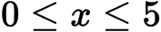 .
Find the x-intercepts of the graph of f .

Markscheme
intercepts when 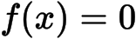 M1
(0.827, 0) (4.78, 0) (accept 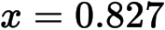, 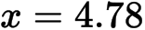 ) A1A1 N3
[3 marks]

