Logic, Sets & Probability Marks
1a. [1 mark]
Markscheme
I was not paid (A1) (C1)
[1 mark]
1b. [1 mark]
Markscheme
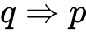 (A1) (C1)
[1 mark]
1c. [2 marks]
Markscheme
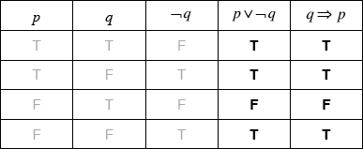 (A1)(A1) (C2)
Note: Award (A1) for each correct column.
[2 marks]
1d. [2 marks]
Markscheme
yes (A1)(ft)
as the last two columns of the truth table are the same (R1)(ft) (C2)
Note: Do not award (A1)(R0). Follow through from part (c)(i).
[2 marks]
2a. [3 marks]
Markscheme
if the teacher is absent then the lesson is cancelled and the students are in the library (A1)(A1)(A1) (C3)
Note: Award (A1) for If…then.
For Spanish candidates, only accept “Si” and “entonces”.
For French candidates, only accept “Si” and “alors”.
For all three languages these words are from the subject guide.
Award (A1) for “and”,
Award (A1) for correct propositions in correct order.
2b. [2 marks]
Markscheme
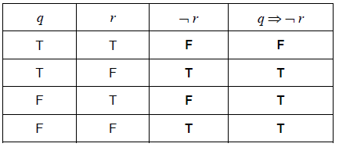
(A1)(A1)(ft) (C2)
Note: Award (A1) for column correct and (A1) for 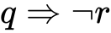 column correct.
Award (A0)(A1)(ft) for a column that correctly follows from an incorrect column.
2c. [1 mark]
Markscheme
not all of the entries are true (or equivalent) (R1) (C1)
Note: Accept “One entry is false”.
3a. [2 marks]
Markscheme
If I do not break my arm, then it will not hurt (A1)(A1) (C2)
Note: Award (A1) for “if… then…”
For Spanish candidates, only accept “Si” and “entonces”.
Award (A1) for “not break my arm” and “not hurt” in correct order.
3b. [2 marks]
Markscheme
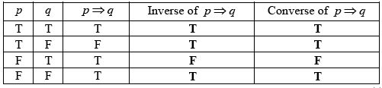
(A1)(A1) (C2)
Notes:Award (A1) for each correct column.
3c. [2 marks]
Markscheme
logically equivalent (A1)(ft)
last two columns of the truth table are identical (R1)(ft) (C2)
Notes: Do not award (A1)(ft)(R0).
Follow through from the last two columns of the table in part (a).
4a. [3 marks]
Markscheme
If the food is well cooked and the drinks are chilled then dinner is not spoilt. (A1)(A1)(A1) (C3)
Note: Award (A1) for “If…then” (then must be seen), (A1) for the two correct propositions connected with “and”, (A1) for “not spoilt”.
Only award the final (A1) if correct statements are given in the correct order.
[3 marks]
4b. [3 marks]
Markscheme
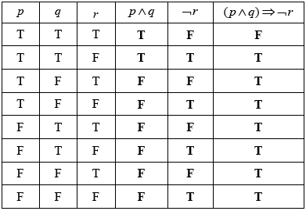 (A1)(A1)(A1)(ft) (C3)
Notes: Award (A1) for each correct column.
The final column must follow through from the previous two columns.
[3 marks]
5a. [3 marks]
Markscheme
(i) 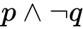 (A1)(A1)
Note: Award (A1) for conjunction, (A1) for negation of q.
(ii) 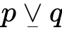 OR 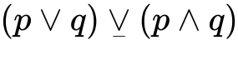 (A1) (C3)
5b. [3 marks]
Markscheme
If Yuiko is not studying Chinese, (then) she is studying French. (A1)(A1)(A1) (C3)
Notes: Award (A1) for “if … (then)” seen, award (A1) for “not studying Chinese” seen, (A1) for correct propositions in correct order.
6a. [2 marks]
Markscheme
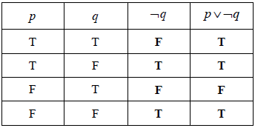 (A1)(A1)(ft) (C2)
Notes: Award (A1) for each correct column. Follow through in 4th column from their 3rd column.
[2 marks]
6b. [2 marks]
Markscheme
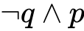 (A1)(A1) (C2)
Note: Award (A1) for 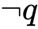 and p in any order, (A1) for .
[2 marks]
6c. [2 marks]
Markscheme
If I can swim 50 metres (then) I do not take swimming lessons. (A1)(A1) (C2)
Note: Award (A1) for If… (then), (A1) for correct propositions in the correct order.
[2 marks]
7a. [4 marks]
Markscheme
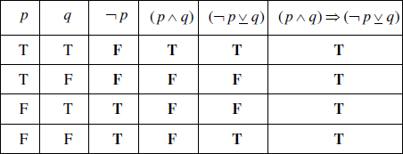 (A1)(A1)(A1)(ft)(A1)(ft) (C4)
Notes: Award (A1) for each correct column.
Award first (A1)(ft) from their third column in the table.
Award second (A1)(ft) from their fourth and fifth column in the table.
[4 marks]
7b. [1 mark]
Markscheme
Tautology (A1)(ft) (C1)
Note: Answer must be consistent with last column in table.
[1 mark]
7c. [1 mark]
Markscheme
All entries (in the final column) are true.(R1)(ft)(C1)
Note: Answer must be consistent with their answer to part (b)(i).
Note: Special case (A1)(R0) may be awarded.
[1 mark]
8a. [2 marks]
Markscheme
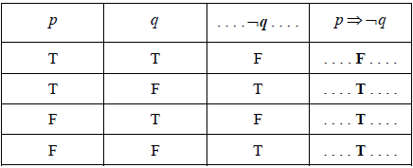 (A1)(A1) (C2)
Note: Award (A1) for ¬q , (A1) for last column.
[2 marks]
8b. [2 marks]
Markscheme
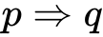 (A1)(A1) (C2)
Note: Award (A1) for 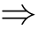 , (A1) for p and q in the correct order.
[2 marks]
8c. [2 marks]
Markscheme
If Cristina does not do well on the logic test then she does not understand logic. (A1)(A1) (C2)
Note: Award (A1) for If…(then), must be an implication, (A1) for the correct propositions in the correct order.
[2 marks]
9a. [4 marks]
Markscheme
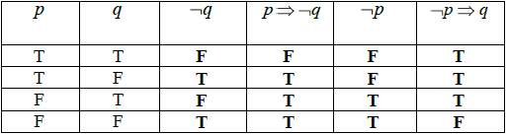 (A1)(A1)(ft)(A1)(A1)(ft) (C4)
Note: Award (A1) for each correct column (second column (ft) from first, fourth (ft) from third). Follow through from second column to fourth column for a consistent mistake in implication.
[4 marks]
9b. [2 marks]
Markscheme
Since second and fourth columns are not identical (R1)(ft)
Not a tautology (A1)(ft) (C2)
Note: (R0)(A1) may not be awarded.
[2 marks]
10a. [2 marks]
Markscheme
If a quadrilateral is not a square (then) the four sides of the quadrilateral are not equal. (A1)(A1) (C2)
Note: Award (A1) for “if…(then)”, (A1) for the correct phrases in the correct order.
[2 marks]
10b. [2 marks]
Markscheme
If the four sides of the quadrilateral are equal (then) the quadrilateral is a square. (A1)(A1)(ft) (C2)
Note: Award (A1) for “if…(then)”, (A1)(ft) for the correct phrases in the correct order.
Note: Follow through in (b) if the inverse and converse in (a) and (b) are correct and reversed.
[2 marks]
10c. [2 marks]
Markscheme
The converse is not always true, for example a rhombus (diamond) is a quadrilateral with four equal sides, but it is not a square. (A1)(R1) (C2)
Note: Do not award (A1)(R0).
[2 marks]
11a. [4 marks]
Markscheme
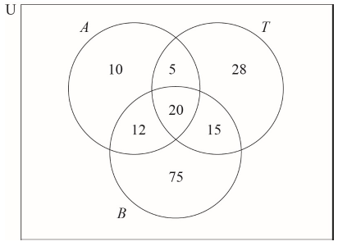
(A1)(A1)(A1)(A1)
Note: Award (A1) for a rectangle with intersecting clearly labelled circles.
Award (A1) for in correct region.
Award (A1) for 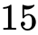, 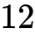, in correct regions.
Award (A1) for 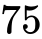, 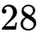, 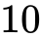 in correct regions.
11b. [6 marks]
Markscheme
(i) (A1)(ft)
Note: Follow through from their Venn diagram.
(ii) (A1)(ft)
Note: Follow through from their Venn diagram.
(iii) 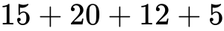 (M1)
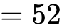 (A1)(ft)(G2)
Note: Award (M1) for addition of their , , and . Follow through from their Venn diagram.
(iv) (M1)
Note: Award BI for their 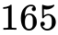, or a sum adding to their , seen.
(A1)(ft)(G2)
Note: Follow through from their Venn diagram.
11c. [2 marks]
Markscheme
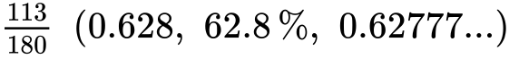 (A1)(ft)(A1)(G2)
Note: Award (A1)(ft) for correct numerator. Follow through from their Venn diagram.
Award (A1) for 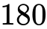 in the denominator.
11d. [2 marks]
Markscheme
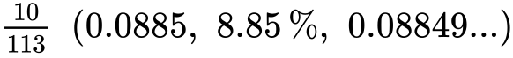 (A1)(ft)(A1)(ft)(G2)
Note: Award (A1)(ft) for correct numerator, (A1)(ft) for correct denominator. Follow through from their Venn diagram or numerator from part (c).
12a. [4 marks]
Markscheme
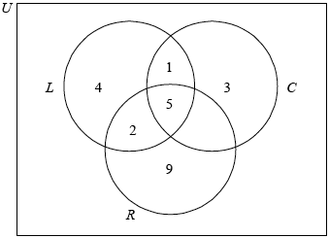 (A1)(A1)(A1)(A1)
Note: Award (A1) for rectangle and three labelled intersecting circles (the rectangle need not be labelled), (A1) for 5, (A1) for 2 and 1,(A1) for 4, 3 and 9.
[4 marks]
12b. [2 marks]
Markscheme
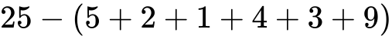 (M1)
Notes: Award (M1) for their 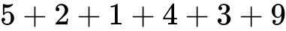 seen even if total is greater than 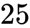.
Do not award (A1)(ft) if their total is greater than .
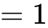 (A1)(ft)(G2)
[2 marks]
12c. [6 marks]
Markscheme
(i) 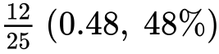 (A1)(ft)(A1)(G2)
Notes: Award (A1)(ft) for numerator, (A1) for denominator.
Follow through from Venn diagram.
(ii) 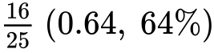 (A1)(A1)(G2)
Notes: Award (A1) for numerator, (A1) for denominator.
There is no follow through; all information is given.
(iii) 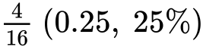) (A1)(A1)(ft)(G2)
Notes: Award (A1) for numerator, (A1)(ft) for denominator.
Follow through from part (c)(ii) only.
[6 marks]
12d. [2 marks]
Markscheme
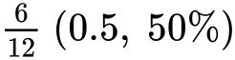 (A1)(A1)(ft)(G2)
Notes: Award (A1) for numerator, (A1)(ft) for denominator.
Follow through from Venn diagram.
[2 marks]
13a. [2 marks]
Markscheme
(i) 3, 4, 5, 6, 7, 8, 9 (A1)
(ii) 3, 4, 6, 8 (A1)(ft) (C2)
Notes: Follow through from part (a)(i).
[2 marks]
13b. [3 marks]
Markscheme
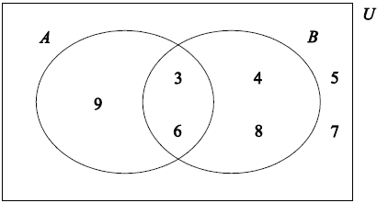
(A1)(ft) for their 3, 6
(A1)(ft) for their 4, 8, 9
(A1)(ft) for their 5, 7 (A1)(ft)(A1)(ft)(A1)(ft) (C3)
Note: Follow through from their universal set and set B in part (a).
[3 marks]
13c. [1 mark]
Markscheme
2 (A1)(ft) (C1)
Note: Follow through from their Venn diagram.
[1 mark]
14a. [1 mark]
Markscheme
(one) (A1) (C1)
Note: , 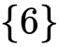 or 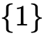 earns no marks.
[1 mark]
14b. [1 mark]
Markscheme
, , , , , 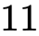 (A1) (C1)
Note: Do not penalise if braces, parentheses or brackets are seen.
[1 mark]
14c. [4 marks]
Markscheme
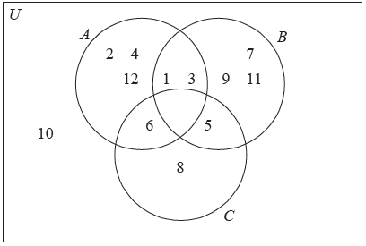 (A1)(A1)(ft)(A1)(ft)(A1)(ft) (C4)
Notes: Award (A1) for the empty set 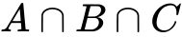 .
Award (A1)(ft) for the correct placement of , , and .
Award (A1)(ft) for the correct placement of , , , , , , .
Award (A1)(ft) for the correct placement of .
Follow through from part (b).
[4 marks]

