Logic, Sets & Probability
1a. [1 mark]
Consider the following propositions.

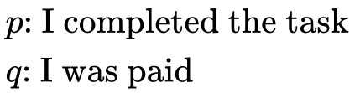

Write down in words 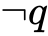.
1b. [1 mark]
Write down in symbolic form the compound statement:
If I was paid then I completed the task.
1c. [2 marks]
Complete the following truth table.
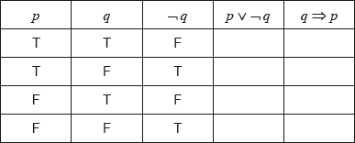
1d. [2 marks]
State whether the statements 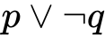 and 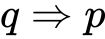 are logically equivalent. Give a reason for your answer.
2a. [3 marks]
Consider the following propositions:
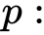 The lesson is cancelled
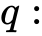 The teacher is absent
The students are in the library.
Write, in words, the compound proposition 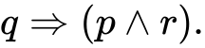
2b. [2 marks]
Complete the following truth table.
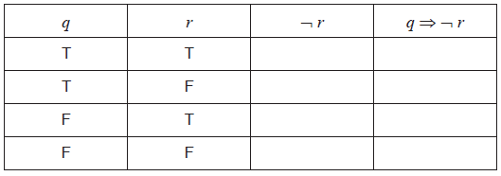
2c. [1 mark]
Hence, justify why 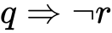 is not a tautology.
3a. [2 marks]
Consider the statement 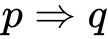.
If I break my arm, then it will hurt.
Write down in words, the inverse of .
3b. [2 marks]
Complete the following truth table.
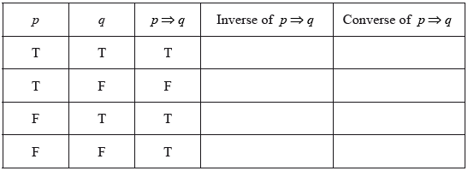
3c. [2 marks]
State whether the converse and the inverse of an implication are logically equivalent.
Justify your answer.
4a. [3 marks]
Consider the three propositions p, q and r.
p: The food is well cooked
q: The drinks are chilled
r: Dinner is spoilt
Write the following compound proposition in words.

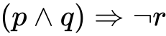

4b. [3 marks]
Complete the following truth table.
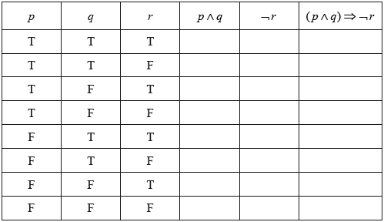
5a. [3 marks]
Consider the following logic propositions:
p : Yuiko is studying French.
q : Yuiko is studying Chinese.
Write down the following compound propositions in symbolic form.
(i) Yuiko is studying French but not Chinese.
(ii) Yuiko is studying French or Chinese, but not both.
5b. [3 marks]
Write down in words the inverse of the following compound proposition.
If Yuiko is studying Chinese, then she is not studying French.
6a. [2 marks]
Consider the propositions p and q.
p: I take swimming lessons
q: I can swim 50 metres
Complete the truth table below.
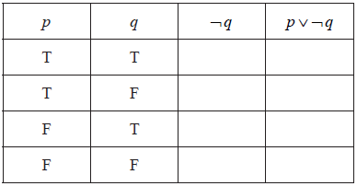
6b. [2 marks]
Write the following compound proposition in symbolic form.
“I cannot swim 50 metres and I take swimming lessons.”
6c. [2 marks]
Write the following compound proposition in words.
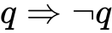
7a. [4 marks]
Complete the truth table below.
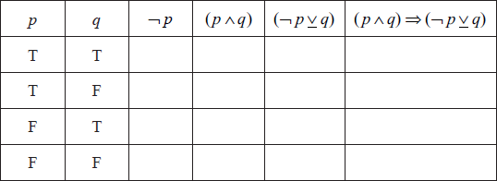
7b. [1 mark]
State whether the statement 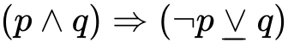 is a logical contradiction, a tautology or neither.
7c. [1 mark]
Give a reason for your answer to part (b)(i).
8a. [2 marks]
Complete the following truth table.
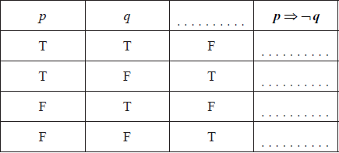
8b. [2 marks]
Consider the propositions
p: Cristina understands logic
q: Cristina will do well on the logic test.
Write down the following compound proposition in symbolic form.
“If Cristina understands logic then she will do well on the logic test”
8c. [2 marks]
Write down in words the contrapositive of the proposition given in part (b).
9a. [4 marks]
Consider two propositions p and q.
Complete the truth table below.
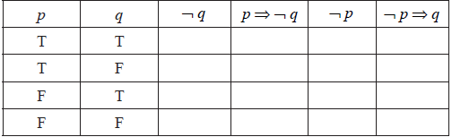
9b. [2 marks]
Decide whether the compound proposition
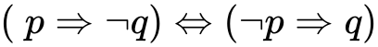
is a tautology. State the reason for your decision.

10a. [2 marks]
Consider the statement p:
“If a quadrilateral is a square then the four sides of the quadrilateral are equal”.
Write down the inverse of statement p in words.
10b. [2 marks]
Write down the converse of statement p in words.
10c. [2 marks]
Determine whether the converse of statement p is always true. Give an example to justify your answer.
11a. [4 marks]
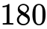 people were interviewed and asked what types of transport they had used in the last year from a choice of airplane 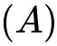, train 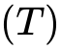 or bus 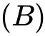. The following information was obtained.
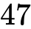 had travelled by airplane
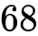 had travelled by train
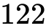 had travelled by bus
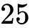 had travelled by airplane and train
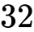 had travelled by airplane and bus
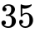 had travelled by train and bus
had travelled by all three types of transport
Draw a Venn diagram to show the above information.
11b. [6 marks]
Find the number of people who, in the last year, had travelled by
(i) bus only;
(ii) both airplane and bus but not by train;
(iii) at least two types of transport;
(iv) none of the three types of transport.
11c. [2 marks]
A person is selected at random from those who were interviewed.
Find the probability that the person had used only one type of transport in the last year.
11d. [2 marks]
Given that the person had used only one type of transport in the last year, find the probability that the person had travelled by airplane.
12a. [4 marks]
A group of tourists went on safari to a game reserve. The game warden wanted to know how many of the tourists saw Leopard (), Cheetah () or Rhino (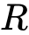). The results are given as follows.
5 of the tourists saw all three
7 saw Leopard and Rhino
1 saw Cheetah and Leopard but not Rhino
4 saw Leopard only
3 saw Cheetah only
9 saw Rhino only
Draw a Venn diagram to show this information.
12b. [2 marks]
There were 25 tourists in the group and every tourist saw at least one of the three types of animal.
Find the number of tourists that saw Cheetah and Rhino but not Leopard.
12c. [6 marks]
There were 25 tourists in the group and every tourist saw at least one of the three types of animal.
Calculate the probability that a tourist chosen at random from the group
(i) saw Leopard;
(ii) saw only one of the three types of animal;
(iii) saw only Leopard, given that he saw only one of the three types of animal.
12d. [2 marks]
There were 25 tourists in the group and every tourist saw at least one of the three types of animal.
If a tourist chosen at random from the group saw Leopard, find the probability that he also saw Cheetah.
13a. [2 marks]
A and B are subsets of U such that A = {multiples of 3}, B = {factors of 24}.
List the elements of
(i) U ;
(ii) B .
13b. [3 marks]
Write down the elements of U on the Venn diagram.
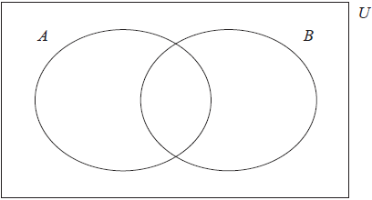
13c. [1 mark]
Write down 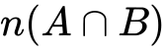.
14a. [1 mark]
is the set of all the positive integers less than or equal to 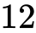.
, 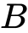 and are subsets of .
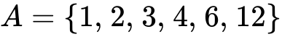
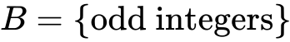
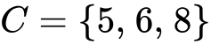

Write down the number of elements in 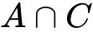 .
14b. [1 mark]
List the elements of .
14c. [4 marks]
Complete the following Venn diagram with all the elements of .
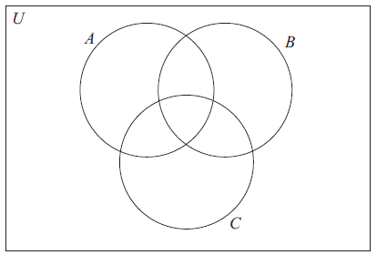

Printed for William Howard Taft High School
© International Baccalaureate Organization 2018
International Baccalaureate® - Baccalauréat International® - Bachillerato Internacional®

