Review 1 - Numbers & Algebra January 2018
1. Markscheme
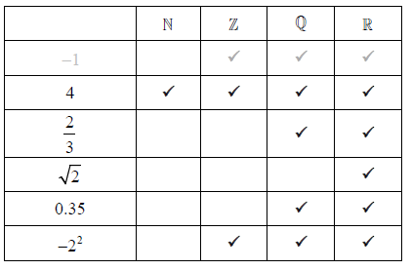
(A1)(A1)(A1)(A1)(A2) (C6)
Row 2 to row 5: Award (A1) for each correct row.
Row 6: Award (A1) for both not selected and selected; award (A1) for both 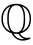 and selected. Do not penalize if crosses (or similar) appear in the empty cells.
2. Markscheme
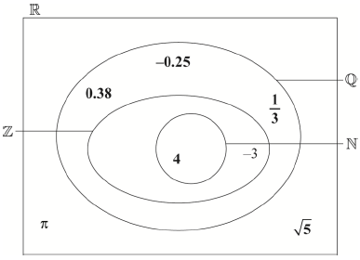
3. [6 marks]
Markscheme
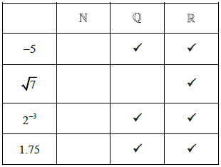
(A1) for column correct.
(A2) for column correct, award (A1) if one is missing, award (A0) if two or more missing.
(A3) for 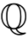 column correct, award (A2) for two correctly placed and no extra entries, award (A1) for one correctly placed and no extra entries or placed in all entries. (A6) (C6)
4. Markscheme
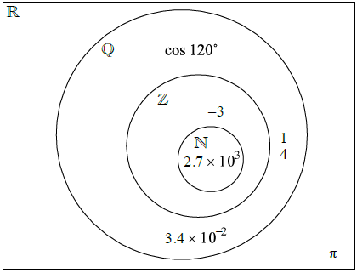
Award (A1) for each number placed once in the correct section. Accept equivalent forms for numbers.
5. Markscheme
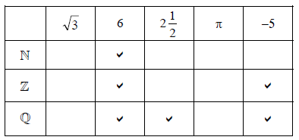
Note: Accept any symbol for ticks. Do not penalize if candidate had also indicated, by a different symbol, that the number is not an element of the set.
Row correct, no extra entries. (A1) (C1)
Row (A1)(A1) (C2)
Note: Award (A1) for each correct tick and no extra entries. Award (A1) only for both ticks correct and 1 extra entry, (A0) otherwise.
Row 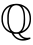 (A1)(A1)(A1) (C3)
Note: Award (A1) for each correct tick and no extra entries. Award (A2) only for all 3 correct and one extra entry. Award (A1) only for 2 correct and one extra entry. (A0) otherwise.
[6 marks]
6a.
Markscheme
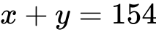 (A1) (C1)
[1 mark]
6b.
Markscheme
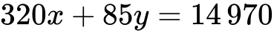 (A1) (C1)
[1 mark]
6c.
Markscheme
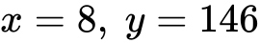 (A1)(ft)(A1)(ft) (C2)
Note: Follow through from parts (a) and (b) irrespective of working seen, but only if both values are positive integers.
Award (M1)(A0) for a reasonable attempt to solve simultaneous equations algebraically, leading to at least one incorrect or missing value.
[2 marks]
6d.
Markscheme
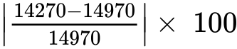 (M1)
Note: Award (M1) for correct substitution into percentage error formula.
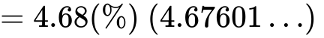 (A1) (C2)
[2 marks]
7a
Markscheme
k = 2.034 × 0.632 (M1)
= 1.29 (1 GBP = 1.29 EUR) (A1) (C2)
Note: Accept 1.29 only
[2 marks]
7b.
Markscheme
Financial penalty (FP) applies in part (b).
400 × 0.632 (M1)
= 252.80 EUR(A1)
2 % of 252.80 = 5.06 EUR(A1)
(FP) She receives 247.74 EUR(A1)
OR
(FP) 0.98 × 252.80 = 247.74 EUR(A1)(A1)(C4)
Note: Accept (A1) for 0.98 seen.
[4 marks]
8a.
Markscheme
Financial accuracy penalty (FP) is applicable where indicated in the left hand column.
Multiplying 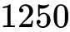 by 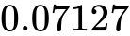 or 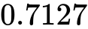 (M1)
(FP) 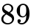 (A1) (C2)
[2 marks]
8b.
Markscheme
Financial accuracy penalty (FP) is applicable where indicated in the left hand column.
Dividing by 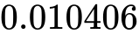 or 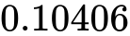 (M1)
(FP) 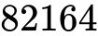 (A1) (C2)
Note: If candidate has divided in (a) and multiplied in (b) award (M1)(A1)(ft) for in (b).
[2 marks]
8c.
Markscheme
Financial accuracy penalty (FP) is applicable where indicated in the left hand column.
(FP) 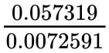 allow 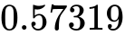 and/or 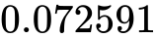 (M1)
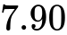 (A1) (C2)
Note: The (M1) is being allowed for misreading values from the table but do not (ft) to candidate’s answers.
[2 marks]
9a.
Markscheme
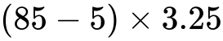 (M1)(M1)
Note: Award (M1) for subtracting 5 from 85, (M1) for multiplying by 3.25.
Award (M1) for 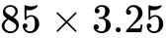, (M1) for subtracting 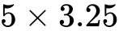.
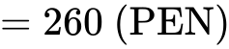 (A1) (C3)
[3 marks]
9b.
Markscheme
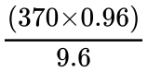 (M1)(M1)
Note: Award (M1) for multiplying by 0.96 (or equivalent), (M1) for dividing by 9.6. If division by 3.25 seen in part (a), condone multiplication by 9.6 in part (b).
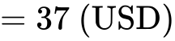 (A1) (C3)
[3 marks]
10a.
Markscheme
(M1)(M1)
Note: Award (M1) for multiplying 8000 by 0.09819, (M1) for multiplying by 0.98 (or equivalent).
769.81 (EUR) (A1) (C3)
[3 marks]
10b.
Markscheme
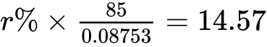 (M1)(M1)
Note: Award (M1) for dividing 85 by 0.08753, and (M1) for multiplying their 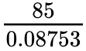 by 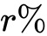 and equating to 14.57.
OR
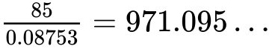 (M1)
Note: Award (M1) for dividing 85 by 0.08753.
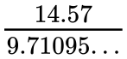OR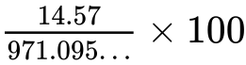 (M1)
Note: Award (M1) for dividing 14.57 by 9.71095… or equivalent.
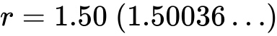 (A1) (C3)
[3 marks]

Printed for William Howard Taft High School
© International Baccalaureate Organization 2018
International Baccalaureate® - Baccalauréat International® - Bachillerato Internacional®

