Review 1 - Numbers & Algebra January 2018
1. [6 marks]
Consider the numbers 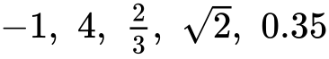 and 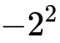.
Complete the following table by placing a tick () to indicate if the number is an element of the number set. The first row has been completed as an example.
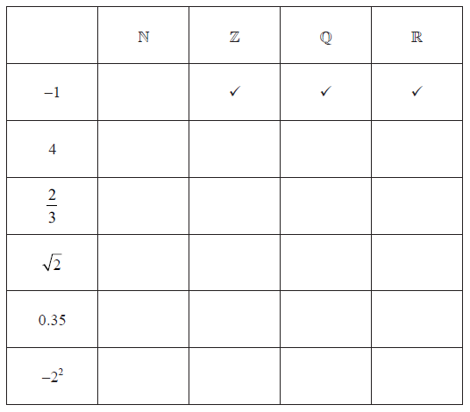

2a. [1 mark]
The following Venn diagram shows the relationship between the sets of numbers
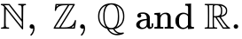
The number –3 belongs to the set of 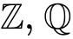 and , but not , and is placed in the appropriate position on the Venn diagram as an example.
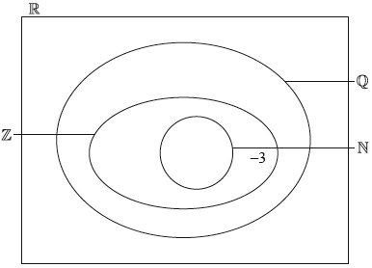
Write down the following numbers in the appropriate place in the Venn diagram.
2b. [1 mark]
2c. [1 mark]
2d. [1 mark]
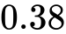
2e. [1 mark]
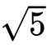
2f. [1 mark]
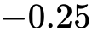
3. [6 marks]
Consider the numbers 3, −5 , 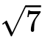, 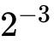 and 1.75.
Complete the table below, placing a tick () to show which of the number sets, 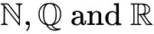 these numbers belong to. The first row has been completed as an example.
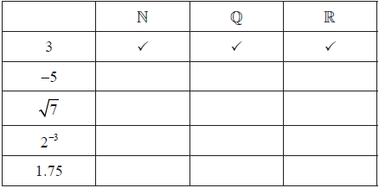

4. [6 marks]
The Venn diagram shows the number sets , , 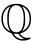 and . Place each of the following numbers in the appropriate region of the Venn diagram.
, −3, π, cos 120°, 2.7 × 10³, 3.4 × 10^{–2}
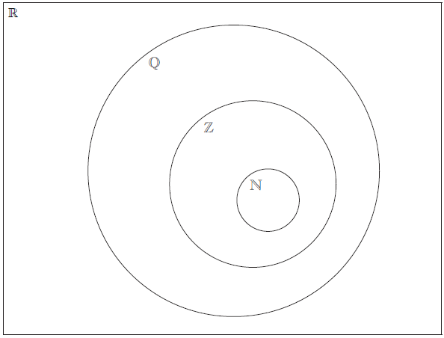
5. [6 marks]
Consider the numbers 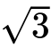, , 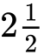, , 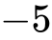, and the sets , , and . Complete the following table by placing a tick in the appropriate box if the number is an element of the set.
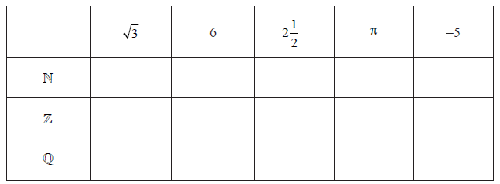
6a. [1 mark]
Passengers of Flyaway Airlines can purchase tickets for either Business Class or Economy Class.
On one particular flight there were 154 passengers.
Let be the number of Business Class passengers and be the number of Economy Class passengers on this flight.
Use the above information to write down an equation in and .
6b. [1 mark]
On this flight, the cost of a ticket for each Business Class passenger was 320 euros and the cost of a ticket for each Economy Class passenger was 85 euros. The total amount that Flyaway Airlines received for these tickets was 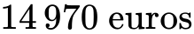.
Use the information about the cost of tickets to write down a second equation in and .
6c. [2 marks]
Find the value of and the value of .
6d. [2 marks]
The airline’s finance officer wrote down the total amount received by the airline for these tickets as 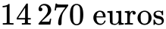.
Find the percentage error.
7a. [2 marks]
The exchange rates between the British pound (GBP) and the United States dollar (USD) and between the USD and the Euro (EUR) are given below.
Find the exchange rate between GBP and EUR in the form 1 GBP = k EUR, where k is a constant. Give your answer correct to two decimal places.
7b. [4 marks]
Isabella changes 400 USD into Euros and is charged 2 % commission.
Calculate how many Euros she receives. Give your answer correct to two decimal places.
8a. [2 marks]
The table below shows some exchange rates for the Japanese Yen (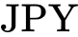).
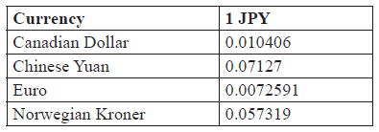
Minbin has 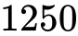 Japanese Yen which she wishes to exchange for Chinese Yuan.
Calculate how many Yuan she will receive. Give your answer to the nearest Yuan.
8b. [2 marks]
Rupert has 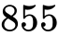 Canadian Dollars which he wishes to exchange for Japanese Yen.
Calculate how many Yen he will receive. Give your answer to the nearest Yen.
8c. [2 marks]
Find how many Norwegian Kroner there are to the Euro. Give your answer correct to 2 decimal places.
9a. [3 marks]
Daniela is going for a holiday to South America. She flies from the US to Argentina stopping in Peru on the way.
In Peru she exchanges 85 United States dollars (USD) for Peruvian nuevo sol (PEN). The exchange rate is 1 USD = 3.25 PEN and a flat fee of 5 USD commission is charged.
Calculate the amount of PEN she receives.
9b. [3 marks]
At the end of Daniela’s holiday she has 370 Argentinean peso (ARS). She converts this back to USD at a bank that charges a 4% commission on the exchange. The exchange rate is 1 USD = 9.60 ARS.
Calculate the amount of USD she receives.
10a. [3 marks]
Claudia travels from Buenos Aires to Barcelona. She exchanges 8000 Argentine Pesos (ARS) into Euros (EUR).
The exchange rate is 1 ARS = 0.09819 EUR. The bank charges a 2% commission on the exchange.
Find the amount of Euros that Claudia receives. Give your answer correct to two decimal places.
10b. [3 marks]
When Claudia returns to Buenos Aires she has 85 EUR left and exchanges this money back into ARS. The exchange rate is 1 ARS = 0.08753 EUR. The bank charges % commission. The commission charged on this exchange is 14.57 ARS.
Find the value of .

Printed for William Howard Taft High School
© International Baccalaureate Organization 2018
International Baccalaureate® - Baccalauréat International® - Bachillerato Internacional®

