Unit 3 Regression Name: ____________________
Review problem Date: ______________
HEIGHTS
Husband | Wife
68.5 | 63.4
67.8 | 61.4
68.3 | 61.8
67.9 | 62.6
67.1 | 59.1
66.9 | 62.2
67.8 | 62.6
68.3 | 61.2
69.2 | 64.4
65.5 | 60.6
66.7 | 60.6
70.2 | 64.8
67.3 | 60.8
73.5 | 68.5
70.2 | 65.4
69.0 | 64.6
67.9 | 63.0
68.4 | 61.4
65.9 | 65.4
69.0 | 64.2

Do women tend to marry men taller than they are? A study was done with 20 married couples. The wife and husband’s heights were measured in inches.

- Create the scatterplot on GRAPH PAPER

- Describe the scatterplot.

Form:

Direction:

Strength:

- Find the LSRL using the calculator and write it below.

- Add the line to the scatterplot. Be accurate.

- Find the correlation (the r).

- Interpret the slope in context.

- Interpret the y-intercept. Does it make sense in in this context?

- What would predict the height of a husband to be if his wife is 63.0 inches tall?

- What was the actual height of the husband for the woman that was 63.0 inches tall from the data?

- What is the residual? Actual - Prediction

- What is R².

- What would predict the height of a husband to be if his wife is 74.5 inches tall?

- How confident are you in that prediction?

ANSWER KEY Name: ____________________
Date: ______________
HEIGHTS
Husband | Wife
68.5 | 63.4
67.8 | 61.4
68.3 | 61.8
67.9 | 62.6
67.1 | 59.1
66.9 | 62.2
67.8 | 62.6
68.3 | 61.2
69.2 | 64.4
65.5 | 60.6
66.7 | 60.6
70.2 | 64.8
67.3 | 60.8
73.5 | 68.5
70.2 | 65.4
69.0 | 64.6
67.9 | 63.0
68.4 | 61.4
65.9 | 65.4
69.0 | 64.2

Do women tend to marry men taller than they are? A study was done with 20 married couples. The wife and husband’s heights were measured in inches.

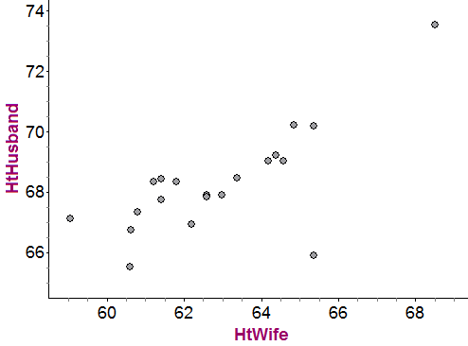
- Find the LSRL using the calculator.

(2) y = 0.575x + 32.106

- Add the line to the scatterplot above. Be sure to show what points were used to draw the line.

(5)

- Find the correlation.
(1) r = 0.732
- Describe the scatterplot.

Positive
(4) Linear
Moderate (r = 0.732)
Outliers at (65.4, 65.9) and (68.5, 73.5)

- Interpret the slope in context.

(3) For every increase of 1 inch in the wife’s height there tends to be an increase of 0.575 inches
in the husbands height.
- What would predict the height of a husband to be if his wife is 63.0 inches tall?

(2) y = 0.575(63.0) + 32.106
y = 68.331 inches

- What was the actual height of the husband for the woman that was 63.0 inches tall from the data? What is the residual?

(2) Actual height = 67.9 inches
e = 67.9 – 68.331
e = -0.431 inches

- Interpret R² in context.

(3) For this model 53.7% of the variability in the husband’s height can be explained by variations in the wife’s height.

- What percent of the variability in husband’s height is explained by other factors?

(1) 42.3%

- What does the R² tell you about the confidence of your prediction for number 6?

(2) I can only be moderately confident in the prediction.

- What would predict the height of a husband to be if his wife is 74.5 inches tall?

(2) y = 0.575(74.5) + 32.106
y = 74.944 inches

- How confident are you in that prediction?

(2) Not confident since 74.5 lies outside the range of the data in the study.

