**Random Variables with the TI-Calculator**

**Example:**

|  |  |  |  |  |  |
| --- | --- | --- | --- | --- | --- |
| X | 2 | 3 | 4 | 5 | 6 |
| Probability | 0.15 | 0.25 | 0.35 | 0.2 | 0.05 |

**Finding the Mean (Expected Value), $μ_{x}$**

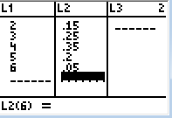

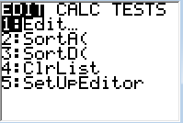

* Press STAT
* Select 1:Edit
* Enter X values in L1 and probabilities in L2

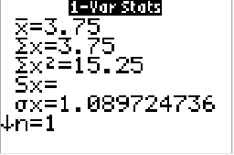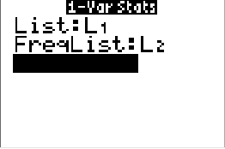

* $\overline{x}=3.75$ is $μ_{X}$, the mean
* $σ_{X}=$ 1.0897 is the stand deviation
* Press STAT
* 🡪 CALC
* Select 1:1-Var Stats
* Enter L1 (X values) for List and L2 (probabilities) for FreqList
* Calculate

$$μ_{x}=3.75$$

$${σ_{x}}^{2}=1.0897$$

**Random Variables with the HP Prime**

**Example:**

|  |  |  |  |  |  |
| --- | --- | --- | --- | --- | --- |
| X | 2 | 3 | 4 | 5 | 6 |
| Probability | 0.15 | 0.25 | 0.35 | 0.2 | 0.05 |

**Finding the Mean (Expected Value), $μ_{x}$, and Variance,**

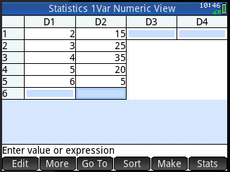****

* Enter X values in D1
* Enter the percent (0.2 = 20%) into D2
* Select Apps
* Select Statistics 1Var

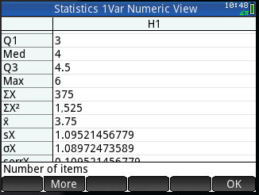****

* is $μ_{X}$, the mean
* $σ_{X}=$ 1.0897 is the stand deviation
* Press Num
* Tap Stats in the bottom right corner
* Press Symb
* Make sure H1 is Checked. Enter D1 into the first box and D2 into the box that says FREQ.