Practice Test with Solutions– Linear Modeling
1a. [2 marks]
There are nine books on a shelf. For each book, x is the number of pages, and y is the selling price in pounds (£). Let r be the correlation coefficient.
Write down the possible minimum and maximum values of r .

Markscheme
min value of r is , max value of r is 1 A1A1 N2
1b. [1 mark]
Given that 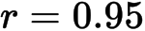 , which of the following diagrams best represents the data.
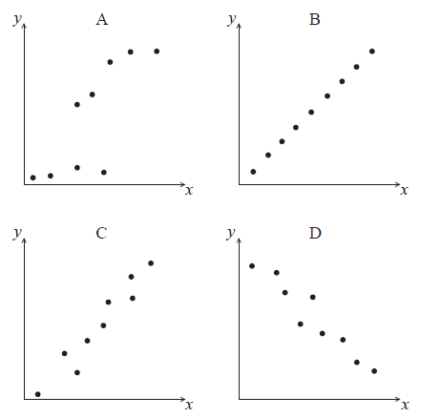

Markscheme
C A1 N1

1c. [2 marks]
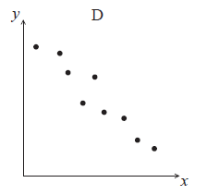
For the data in diagram D , which two of the following expressions describe the correlation between x and y ?
perfect, zero, linear, strong positive, strong negative, weak positive, weak negative

Markscheme
linear, strong negative A1A1 N2
2a. [2 marks]
Each day, a factory recorded the number ( ) of boxes it produces and the total production cost ( ) dollars. The results for nine days are shown in the following table.
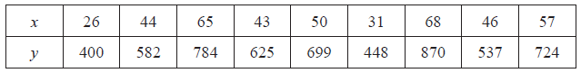
Write down the equation of the regression line of y on x .

Markscheme
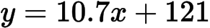 A1A1 N2

2b. [2 marks]
Use your regression line from part (a) as a model to answer the following.
Interpret the meaning of
(i) the gradient;
(ii) the y-intercept.

Markscheme
(i) additional cost per box (unit cost) A1 N1
(ii) fixed costs A1 N1
2c. [2 marks]
Estimate the cost of producing 60 boxes.

Markscheme
attempt to substitute into regression equation M1
e.g. 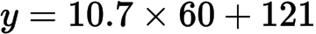 , 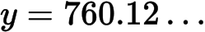
(accept 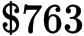 from 3 s.f. values) A1 N2
2d. [3 marks]
The factory sells the boxes for $19.99 each. Find the least number of boxes that the factory should produce in one day in order to make a profit.

Markscheme
setting up inequality (accept equation) M1
e.g.
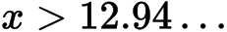 A1
13 boxes (accept 14 from 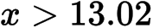 , using 3 s.f. values) A1 N2

2e. [4 marks]
Comment on the appropriateness of using your model to
(i) estimate the cost of producing 5000 boxes;
(ii) estimate the number of boxes produced when the total production cost is $540.

Markscheme
(i) this would be extrapolation, not appropriate R1R1 N2
(ii) this regression line cannot predict x from y, not appropriate R1R1 N2

3a. [2 marks]
The following table shows the average weights ( y kg) for given heights (x cm) in a population of men.
Heights (x cm) | 165 | 170 | 175 | 180 | 185
Weights (y kg) | 67.8 | 70.0 | 72.7 | 75.5 | 77.2

The relationship between the variables is modeled by the regression equation 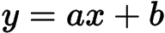.
Write down the value of and of .

Markscheme
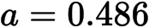 (exact) A1 N1
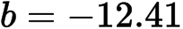 (exact), A1 N1

3b. [2 marks]
The relationship between the variables is modeled by the regression equation .
Hence, estimate the weight of a man whose height is 172 cm.

Markscheme
correct substitution (A1)
eg 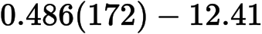
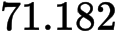
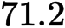 (kg) A1 N2
3c. [1 mark]
Write down the correlation coefficient.

Markscheme
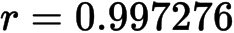
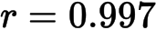 A1 N1
3d. [2 marks]
State which two of the following describe the correlation between the variables.
strong | zero | positive
negative | no correlation | weak

Markscheme
strong, positive (must have both correct) A2 N2

