Lesson 10.1: Sampling Distribution for a Difference in Proportions
Important ideas:

Check Your Understanding
Your teacher brings two bags of colored goldfish crackers to class. Bag 1 has 25% red crackers and Bag 2 has 35% red crackers. Each bag contains more than 1000 crackers. Using a paper cup, your teacher takes an SRS of 50 crackers from Bag 1 and a separate SRS of 40 crackers from Bag 2. Let $\hat{p_{1}}-\hat{p_{2}}$ be the difference in the sample proportions of red crackers.

- What is the shape of the sampling distribution of $\hat{p_{1}}-\hat{p_{2}}$? Why?

- Find the mean of the sampling distribution.

- Calculate and interpret the standard deviation of the sampling distribution.

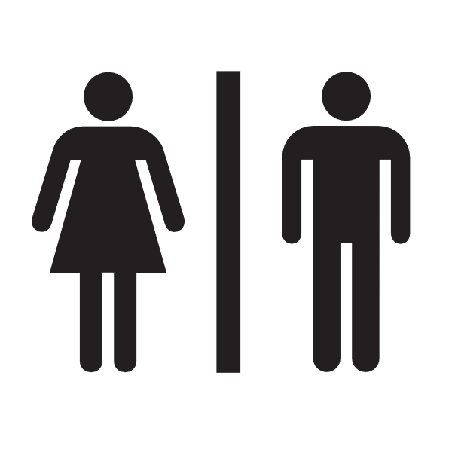
Lesson 10.1: Which gender uses Twitter more?

A recent random sample of 200 U.S. females revealed 110 use Twitter regularly. A separate random sample of 150 males revealed that 60 use Twitter regularly. Construct a 95% confidence interval for the true difference in proportions who use Twitter regularly (females – male). he front of the room. Is it a fair deck?

STATE: State the parameter you want to estimate and the confidence level.

Parameter: Statistic:

Confidence level:

PLAN: Identify the appropriate inference method and check conditions.

Name of procedure:

Check conditions:

DO: If the conditions are met, perform the calculations.

General Formula:

Specific Formula:

Work:

Answer:

CONCLUDE: Interpret your interval in the context of the problem.

Interpret:

Lesson 10.1: Confidence Interval for a Difference in Proportions
Important ideas:

Check Your Understanding
A Pew Research Center poll asked independent random samples of working women and men how much they value job security. Of the 806 women, 709 said job security was very or extremely important, compared with 802 of the 944 men surveyed. Construct and interpret a 95% confidence interval for the difference in the proportion of all working women and men who consider job security very or extremely important.

Homework #1 - Who likes rap music more?

Who likes rap music more—young people or old people? A study compared 634 randomly chosen young people aged 15 to 25 with 567 randomly selected old people aged 26 – 39. It found that 368 of the young people and 130 of the old people listened to rap music every day.

1. Construct and interpret a 99% confidence interval for the true difference between the proportions of young and old people who listen to rap every day.

