Homework # 3 - AP Statistics 5.2 Worksheet Name
Venn Diagrams, and two way tables Per Date

- Canada has two official languages, English and French. Choose a Canadian at random and ask, “What is your mother tongue?” Here is the distribution of responses, combining many separate languages from the broad Asia/Pacific region:
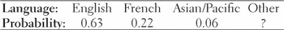
  - What probability should replace “?” in the distribution? Why?

  - What is the probability that a Canadian’s mother tongue is not English?

  - What is the probability that a Canadian’s mother tongue is a language other than English or French?

- Students in an urban school were curious about how many children regularly eat breakfast. They conducted a survey, asking, “Do you eat breakfast on a regular basis?” All 595 students in the school responded to the survey. The resulting data are shown in the two-way table below.
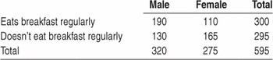
If we select a student from the school at random, what is the probability that we choose
  - a female?

  - someone who eats breakfast regularly?

  - a female who eats breakfast regularly?

  - a female or someone who eats breakfast regularly?

  - Construct a Venn diagram that models the chance process using events B:eats breakfast regularly, and M: is male.

  - Find P(B ∪ M). Interpret this value in context.

  - Find P(BC ∩ MC). Interpret this value in context.

- A company that offers courses to prepare students for the Graduate Management Admission
Test (GMAT) has the following information about its customers: 20% are currently undergraduate students in business; 15% are undergraduate students in other fields of study; 60% are college graduates who are currently employed; and 5% are college graduates who are not employed. Choose a customer at random.
  - Create a table to display the data:

  - What’s the probability that the customer is currently an undergraduate? Which rule of probability did you use to find the answer?

  - What’s the probability that the customer is not an undergraduate business student? Which rule of probability did you use to find the answer?

- An American roulette wheel has 38 slots with numbers 1 through 36, 0, and 00, as shown in the figure. Of the numbered slots, 18 are red, 18 are black, and 2—the 0 and 00—are green. When the wheel is spun, a metal ball is dropped onto the middle of the wheel. If the wheel is balanced, the ball is equally likely to settle in any of the numbered slots. Imagine spinning a fair wheel once. Define events B: ball lands in a black
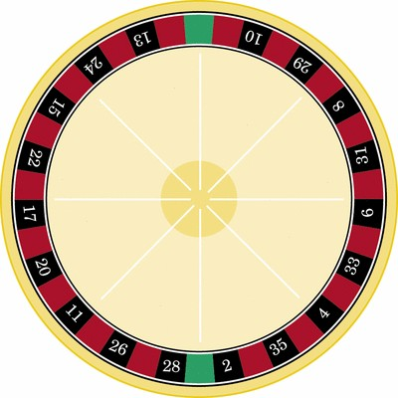
slot, and E: ball lands in an even-numbered slot. (Treat 0 and 00 as even numbers.)

  - Make a two-way table that displays the sample space in terms of events B and E.

  - Find P(B) and P(E).

  - Describe the event “B and E” in words. Then find P(B and E). Show your work.

  - Explain why P(B or E) ≠ P(B) + P(E). Then use the general addition rule to compute P(B or E).

- A 2008 survey suggests that 85% of college students have posted a profile on Facebook, 54% use MySpace regularly, and 42% do both. Suppose we select a college student at random.
  - Make a two-way table for this chance process.

  - Construct a Venn diagram to represent this setting.

  - Consider the event that the randomly selected college student has posted a profile on at least one of these two sites. Write this event in symbolic form using the two events of interest that you chose in (b).

  - Find the probability of the event described in (c). Explain your method.

