Practice Test – Unit 2 - Functions
1a. [4 marks]
Let 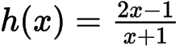 , 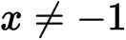 .
Find 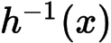 .

1b. [7 marks]
(i) Sketch the graph of h for 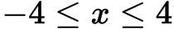 and 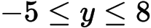 , including any asymptotes.
(ii) Write down the equations of the asymptotes.
(iii) Write down the x-intercept of the graph of h .

2a. [3 marks]
Let 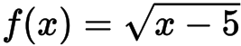 , for 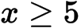 .
Find 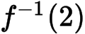 .
2b. [3 marks]
Let be a function such that 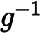 exists for all real numbers. Given that 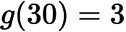 , find 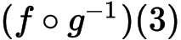 .

3a. [3 marks]
Let 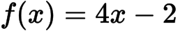 and 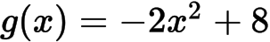 .
Find 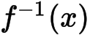 .
3b. [3 marks]
Find 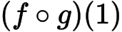
4a. [1 mark]
The diagram below shows the graph of a function , for 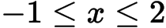 .
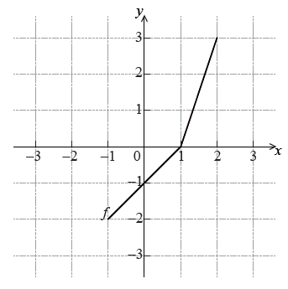
Write down the value of 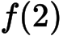.
4b. [2 marks]
Write down the value of 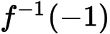 .
4c. [3 marks]
Sketch the graph of 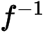 below.

5a. [2 marks]
Let 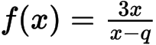, where 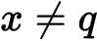.
Write down the equations of the vertical and horizontal asymptotes of the graph of .
5b. [2 marks]
The vertical and horizontal asymptotes to the graph of intersect at the point 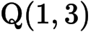.
Find the value of .

6a. [2 marks]
Let 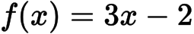 and 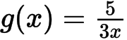, for 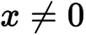.
Find 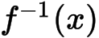.
6b. [2 marks]
Show that 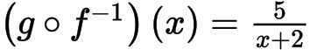.
6c. [2 marks]
Let 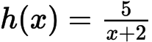, for 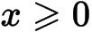. The graph of h has a horizontal asymptote at 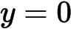.
Find the -intercept of the graph of .

7a. [2 marks]
Let 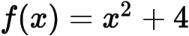 and 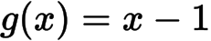 .
Find  

