New test - October 23, 2016
1a. [4 marks]
Let 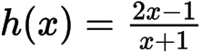 , 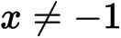 .
Find 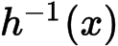 .

Markscheme
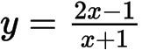
interchanging x and y (seen anywhere) M1
e.g. 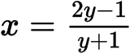
correct working A1
e.g. 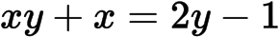
collecting terms A1
e.g. 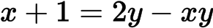 , 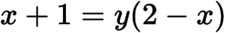
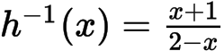 A1 N2
[4 marks]

1b. [7 marks]
(i) Sketch the graph of h for 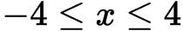 and 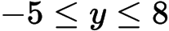 , including any asymptotes.
(ii) Write down the equations of the asymptotes.
(iii) Write down the x-intercept of the graph of h .

Markscheme
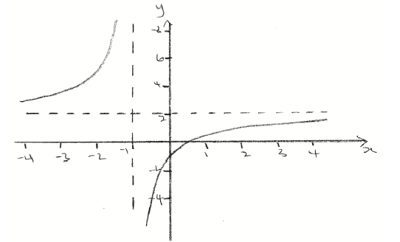 A1A1A1A1 N4
Note: Award A1 for approximately correct intercepts, A1 for correct shape, A1 for asymptotes, A1 for approximately correct domain and range.
(ii) , 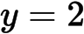 A1A1 N2
(iii) A1 N1
[7 marks]

2a. [3 marks]
Let 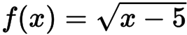 , for 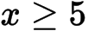 .
Find 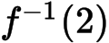 .

Markscheme
METHOD 1
attempt to set up equation (M1)
eg 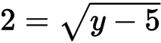 , 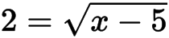
correct working (A1)
eg 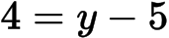 , 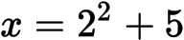
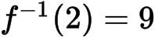 A1 N2
METHOD 2
interchanging and (seen anywhere) (M1)
eg 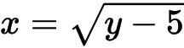
correct working (A1)
eg 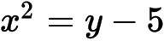 , 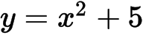
A1 N2
[3 marks]

2b. [3 marks]
Let be a function such that 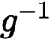 exists for all real numbers. Given that 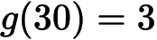 , find 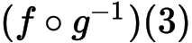 .

Markscheme
recognizing 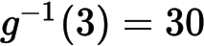 (M1)
eg 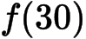
correct working (A1)
eg 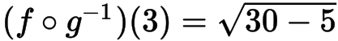 , 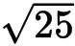
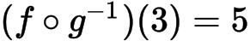 A1 N2
Note: Award A0 for multiple values, eg 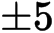 .

3a. [3 marks]
Let 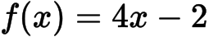 and 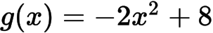 .
Find 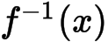 .

Markscheme
interchanging and (seen anywhere) (M1)
eg 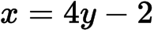
evidence of correct manipulation (A1)
eg 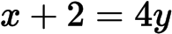
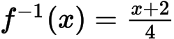 (accept 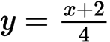 , 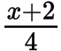 , 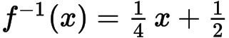 A1 N2
[3 marks]
3b. [3 marks]
Find 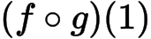 .

Markscheme
METHOD 1
attempt to substitute into 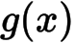 (M1)
eg 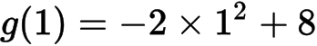
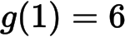 (A1)
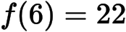 A1 N3
METHOD 2
attempt to form composite function (in any order) (M1)
eg 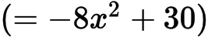
correct substitution
eg , 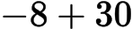
A1 N3
[3 marks]

4a. [1 mark]
The diagram below shows the graph of a function , for 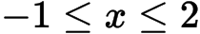 .
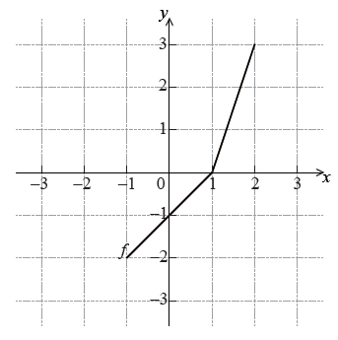
Write down the value of 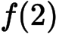.

Markscheme
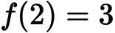 A1 N1
[1 mark]
4b. [2 marks]
Write down the value of 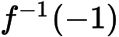 .

Markscheme
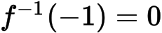 A2 N2
[2 marks]
.
4c. [3 marks]
Sketch the graph of 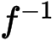 on the grid below.

Markscheme
EITHER
attempt to draw on grid (M1)
OR
attempt to reverse x and y coordinates (M1)
eg writing or plotting at least two of the points
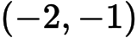 , 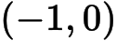 , 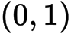 , 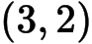
THEN
correct graph A2 N3
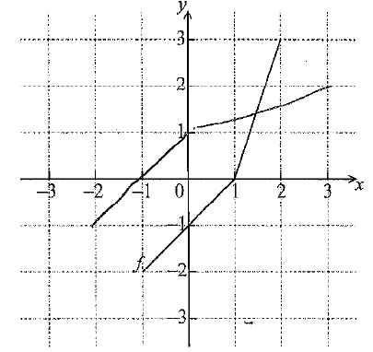
[3 marks]
5a. [2 marks]
Let 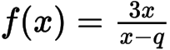, where 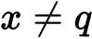.
Write down the equations of the vertical and horizontal asymptotes of the graph of .

Markscheme
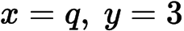 (must be equations) A1A1 N2
[2 marks]
5b. [2 marks]
The vertical and horizontal asymptotes to the graph of intersect at the point 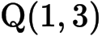.
Find the value of .

Markscheme
recognizing connection between point of intersection and asymptote (R1)
eg
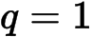 A1 N2
[2 marks]

6a. [2 marks]
Let 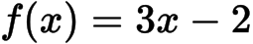 and 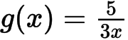, for 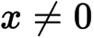.
Find 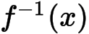.

Markscheme
interchanging and (M1)
eg 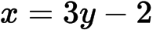
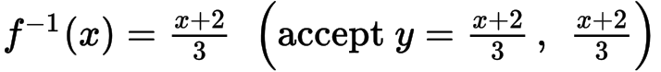 A1 N2
[2 marks]
6b. [2 marks]
Show that 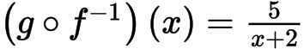.

Markscheme
attempt to form composite (in any order) (M1)
eg 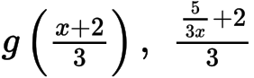
correct substitution A1
eg 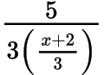
AG N0
[2 marks]

6c. [2 marks]
Let 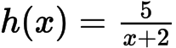, for 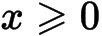. The graph of h has a horizontal asymptote at 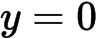.
Find the -intercept of the graph of .

Markscheme
valid approach (M1)
eg 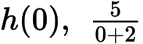
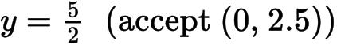 A1 N2
[2 marks]

7a. [2 marks]
Let 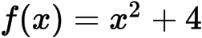 and 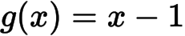 .
Find 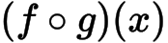 .

Markscheme
attempt to form composition (in any order) (M1)
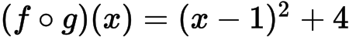 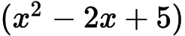 A1 N2
[2 marks]

