**Formative Assessment #3 Linear Regression - Fuel Economy NAME: _________________________**

Here are advertised horsepower ratings and expected gas mileage for several 2007 vehicles as reported by Kelly Blue Book. They are in the group FUEL (lists LGAS and LHORSE).

|  |  |  |  |  |  |
| --- | --- | --- | --- | --- | --- |
| **Vehicle** | **Horsepower** | **Highway Gas Mileage (mpg)** | **Vehicle** | **Horsepower** | **Highway Gas Mileage (mpg)** |
| Audi A4 | 200 | 32 | Honda Accord | 166 | 34 |
| BMW 328 | 230 | 30 | Hyundai Elantra | 138 | 36 |
| Buick LaCrosse | 200 | 30 | Lexus IS 350 | 306 | 28 |
| Chevy Cobalt | 148 | 32 | Lincoln Navigator | 300 | 18 |
| Chevy TrailBlazer | 291 | 22 | Mazda Tribute | 212 | 25 |
| Ford Expedition | 300 | 20 | Toyota Camry | 158 | 34 |
| GMC Yukon | 295 | 21 | Volkswagen Beetle | 150 | 30 |
| Honda Civic | 140 | 40 |  |  |  |

1. Create a scatterplot of horsepower (exp.) vs. mpg (resp.) and draw it below.



1. Describe the form, direction, and strength. Are there any unusual features?
2. Find the equation of the LSRL using the calculator.
3. What is the slope of the line? Interpret it in the context of the problem.
4. What is the y-intercept of the line? Interpret it in the context of the problem.
5. What is the correlation?
6. What mpg does the LSRL predict for a car with 295 horsepower? (show work)
7. What mpg does the LSRL predict for a car with 140 horsepower? (show work)
8. Find the residuals (errors = actual Y – predicted Y) for each of the last two problems.
9. For each ***prediction*** was it an overestimation or an underestimation? How can you tell?

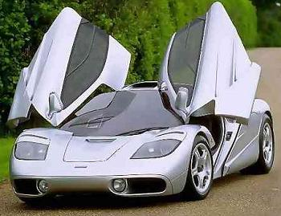

1. The McLaren F1 has a horsepower of 627. What would the LSRL predict as its mpg?
2. Why might you not trust the validity of prediction you made in #11?
3. It actually has a mpg of 12. What is the residual? Is this an overestimation or underestimation?
4. What is the coefficient of determination (r2)? Interpret this number.