Formative Assessment #2 NAME: _______________________

Looking back at Formative #1
Class A Class B Class C
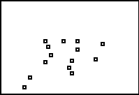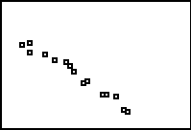
r = 0.7131 r = 0.4653 r = -0.9855

Class D Class E Class F
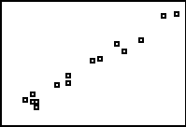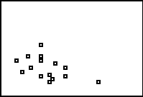
r = -0.7198 r = 0.9888 r = -0.4723

- Which of the classes above are going in a positive direction? How about in a negative direction?

- Look at the correlations (r) listed below each of the negative graphs. Now look at the correlations (r) listed below each of the positive graphs. Using this, what does the sign of the correlation tell us about the graph?

- Which two classes were described as “weak?” How about “moderate?” How about “strong?”

- Look at the numerical values of the correlation (r) of the weak graphs. Now look at the numerical values of the correlation (r) of the moderate graphs. Now look at the numerical values of the correlation (r) of the strong graphs. What do you notice about the numerical values of each of these pairs? (ignore the signs)

- Therefore, what can you conclude about the numerical value of the correlation (r)? What does it tell us about the relationship between the X and Y variables?

- What do you think the maximum numerical value is for the correlation? To help you: look at the two graphs below. They are perfectly straight lines. What would their correlations be (numerically)?
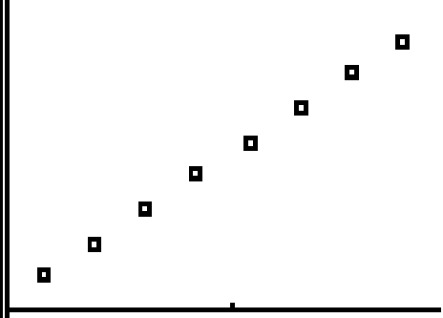 r = ______ r = _____
- Finish these sentences: The stronger the graph, the closer the correlation is to _______ . The weaker the graph the closer the correlation is to _________.

- Below is another class of scores (called class G). Describe the plot.

- Below is another class of scores (called class K). Describe the plot
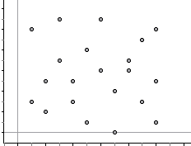

- Both class G and class K above have correlations that are close to 0. What does this show us about what correlation really measures? What type of relationship does it measure?

- Finish these sentences: Strong _____________ plots have correlations close to 1 (or -1). Weak ____________

plots have correlations close to 0. Correlation measures how _____________ a relationship is.

- The following scatterplots are of the same data but with the two variables switched.
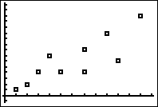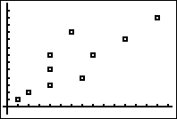
L2
L2
L1
L1

How would you describe the plot on the left? How about the plot on the right? Would you say that there is any difference in the descriptions?

The correlations for both are r = 0.8355. What does that tell you about how correlation treats the x and y variables?

- Estimate the correlations of the following graphs:
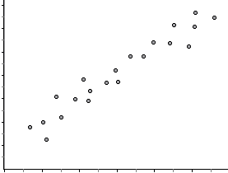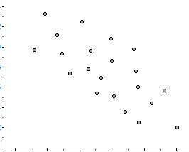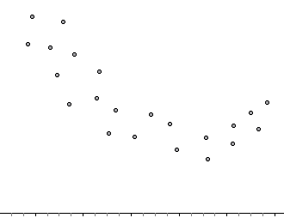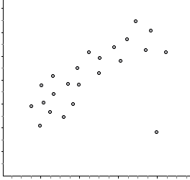

r = ___________ r = ______________ r = ______________ r = ____________

- The graph below is for Class H.
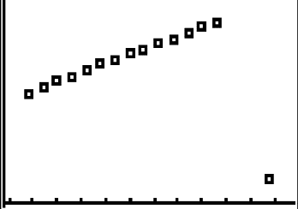
  - Describe the plot

  - Ignoring the outlier, estimate the correlation

  - Including the outlier, estimate the correlation

  - The actual correlation is 0.0365. Does this surprise you?

- The graph below is for Class I.
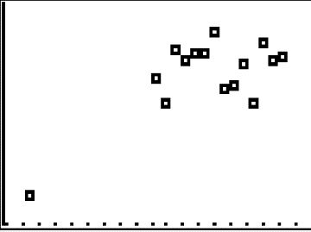
  - Describe the plot

  - Ignoring the outlier, estimate the correlation

  - Including the outlier, estimate the correlation

  - The actual correlation is 0.7046. Does this surprise you?

- Removing the outlier for class H gives a correlation of 0.997. Removing the outlier from class I gives a correlation of 0.1304.
  - Do these values seem more appropriate?

  - What does this tell you about the effects of outliers on correlation? Is correlation a resistant or non-resistant statistic?

- The graph below is for Class J.
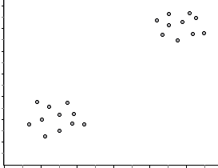
  - Describe the plot

  - Estimate the correlation

  - The actual correlation is 0.9544. Does this surprise you?

