**Formative #1 - Interpreting Scatterplots**

**Class A Class B Class C**

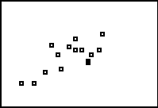 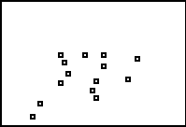 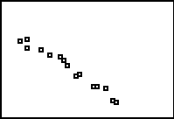

**Class D Class E Class F**

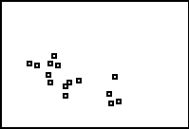 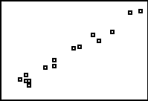 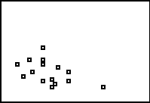

Consider the above scatterplots of hypothetical scores on the first and second exams of a course. The horizontal axis represents the first exam and the vertical axis represents the second exam. Each axis is formatted form 50 to 100 with a scale of 5.

Describe the scatterplots above (form, direction, strength), then fill in the table below with the appropriate letter of each graph

A:

|  |  |  |  |
| --- | --- | --- | --- |
|  | **Strong** | **Moderate** | **Weak** |
| **Negative** |  |  |  |
| **Positive** |  |  |  |

B:

C:

D:

E:

F:

For the pairs of variables below, indicate what you would expect for the direction (positive, negative, scattered) and the strength (none, weak, moderate, strong) of the association.

1. Height and armspan
2. Height and GPA
3. SAT score and college GPA
4. Latitude and average January temperature of American cities
5. Lifespan and weekly cigarette consumption
6. Serving size and calories of fast food sandwiches
7. Air fare and distance to destination

**Part 2 NAME: _______________________**

On page 146 there is an example that compares the body weight and backpack weight of eight ninth-grade boys going on a hiking trip.

Body weight (lbs) 120 187 109 103 131 165 158 116

Backpack weight (lbs) 26 30 26 24 29 35 31 28

On the graph below create the scatterplot of data.

For each boy make a dot at his body weight and backpack weight.

The first boy’s point has been placed at (120,26).

Notice that the two sides are labeled.



BACKPACK WEIGHT

BODY WEIGHT

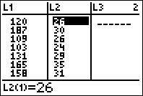

**Creating Scatterplots with the TI Calculator**

1. Put the data into two lists in your calculator.
   1. Body weight into L1
   2. 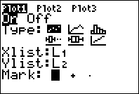Backpack weight into L2

BorderBorder

1. Got to the Stat Plots
2. Turn on Plot 1
3. Change the Type to Scatterplot(the first graph)
4. Make the Xlist: L1
5. Make the Ylist: L2

BorderBorder

1. Press

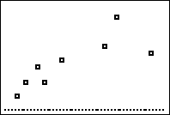

1. Your graph should look like the following and it should match the scatterplot you drew by hand.

Border

1. Press
2. 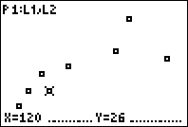At the top of the graph it lists the Plot, the X-List, and the Y-List. (P1:L1,L2) You will see that the first boy’s point is marked and it’s values listed below.
3. Scroll to the right and it will go to the next boy in the order that you entered the data.

**Practice**

1. **This data is the Year and the Average Tuition at an Arizona college.**

|  |  |  |  |  |  |  |  |  |  |  |  |
| --- | --- | --- | --- | --- | --- | --- | --- | --- | --- | --- | --- |
| YEAR | 1990 | 1991 | 1992 | 1993 | 1994 | 1995 | 1996 | 1997 | 1998 | 1999 | 2000 |
| TUITION | 6546 | 6996 | 6996 | 7650 | 7500 | 7978 | 8377 | 8710 | 9110 | 9411 | 9800 |

1. **Following the directions above, create a scatterplot of the data. Sketch it below. Be sure to label your X and Y axes with numbers and variable names!!**
2. **Describe the plot of Year vs. Tuition (form, direction, strength)**
3. **As YEAR increases, what tends to happen to the tuition?**
4. **The data below come from Florida Fish and Wildlife Conservation Commission. It is the number of Manatees in Florida killed in a specific year, versus the number of powerboats registered (in thousands) in Florida that year. The Conservation Commission feels that powerboats threaten the existence of manatees.**

|  |  |
| --- | --- |
| **Manatees** | **Powerboats** |
| 13 | 447 |
| 21 | 460 |
| 24 | 481 |
| 16 | 498 |
| 24 | 513 |
| 20 | 512 |
| 15 | 527 |
| 34 | 559 |
| 33 | 585 |
| 33 | 614 |
| 39 | 646 |
| 43 | 675 |
| 50 | 711 |
| 47 | 719 |
| 53 | 716 |
| 38 | 716 |
| 35 | 716 |
| 49 | 735 |
| 81 | 860 |
| 95 | 923 |
| 73 | 940 |
| 69 | 946 |
| 79 | 974 |

**Following the directions above, create a scatterplot of the data. Sketch it below. Be sure to label your X and Y axes with numbers and variable names!!**

**Describe the plot of Manatees vs. Powerboats (form, direction, strength)**

**Do powerboats seem to have an effect on manatees? Justify your answer!**

1. **Researchers at the University of Delaware wondered if temperatures might influence the age at which babies learn to crawl. Perhaps the extra clothing that the babies wear in the winter months would restrict movement and delay crawling age? Data is below. They measured the average temperature when the babies were 6 months old (in degrees F), and the average crawling age for babies that were 6 months old at that time (in weeks).**

|  |  |  |
| --- | --- | --- |
| **Birth month** | **6 month temperature** | **Average crawling age** |
| January | 66 | 29.84 |
| February | 73 | 30.52 |
| March | 72 | 29.7 |
| April | 63 | 31.84 |
| May | 52 | 28.58 |
| June | 39 | 31.44 |
| July | 33 | 33.64 |
| August | 30 | 32.82 |
| September | 33 | 33.83 |
| October | 37 | 33.35 |
| November | 48 | 33.38 |
| December | 57 | 32.32 |

1. **Create a scatterplot of the data. Sketch it below. Be sure to label your X and Y axes with numbers and variable names.**
2. **Describe the plot (form, direction, strength)**
3. **Does there appear to be an association between temperature and crawling age? Were the researchers correct in their thoughts? Explain!**