**Confidence Intervals – TI Series**

**Finding a Critical Value:**

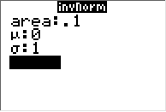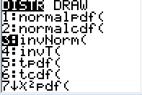

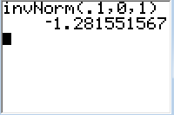

* 2nd DISTR (VARS button)
* Select 3:invNorm(
* Press ENTER
* Z* = -1.28
* Type in lower bound proportion for the area: (1 – C)/2
* Highlight Paste and push ENTER

This also works for *t*-distributions.

* 2nd DISTR
* Select 4:invT(
* Type in tail probability and df:

**Ex:** For 95% confidence and *n* = 5, type invT(0.025, 4)

**Finding a one-sample z-interval for *p***

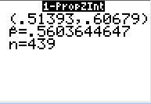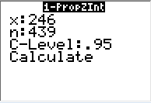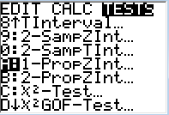

* Fill in information
* Calculate (Press ENTER)
* STAT 🡪 TESTS
* Select A:1-PropZInt

**Finding a one-sample z-interval for *µ***

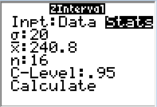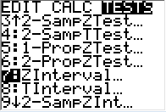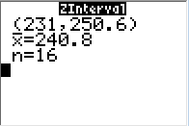

* STAT 🡪 TESTS
* Select 7:ZInterval
* Fill in information
* Calculate (Press ENTER)

**Finding a one-sample t-interval for *µ***

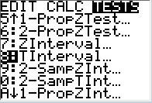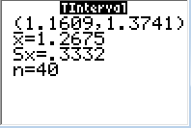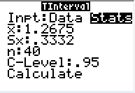

* STAT 🡪 TESTS
* Select 8:TInterval
* Fill in information
* Calculate (Press ENTER)

**LOOK:** With One-sample *z*-intervals for *µ*, there is a *σ*. For *t*-intervals, there is an *sx.*

**Note:** For confidence intervals for *µ,* there is an option for ***Data***. If the problem gives you data instead of statistics, select DATA and enter data into L1 (STAT, EDIT).

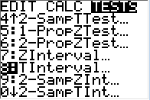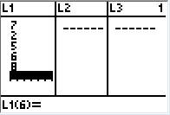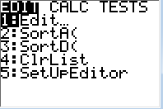

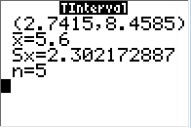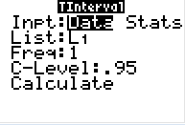

**Make sure that the List you put your data in is the same list you have when you indicate you’re using data!**

**Confidence Intervals – HP Prime**

**Finding a Critical Values:**



* 
* Select Math 🡪 5 Probability 🡪7 Inverse 🡪 1 Normal
* Type in lower bound proportion: (1 – C)/2
* Push ENTER

This also works for *t*-distributions.

* 
* Select Math 🡪 5 Probability 🡪 7 Inverse 🡪 2 T

**Note:** Type in df and tail probability

**Ex:** For 95% confidence and *n* = 5, type invT(4, .025)



* Confidence Intervals are found under the Inference App.
* Select Confidence Interval as your method.

**Finding a one-sample *z*-interval for *p* (ON THE PRIME, THEY LABEL *p* as π**



Select Type: Z-Int: 1 π Select . Fill in info. Push Calc

**Finding a one-sample z-interval for *µ***



Select Type: Z-Int: 1 µ Select . Fill in info. Push Calc

**Finding a one-sample t-interval for *µ***



Select Type: T-Int: 1 µ Select . Fill in info. Push Calc

**LOOK:** With One-sample *z*-intervals for *µ*, there is a *σ*. For *t*-intervals, there is an *s.*

**Note:** For confidence intervals for *µ,* there is an option to ***Import***. If the problem gives you data instead of statistics, select Import and enter data into the Statistics 1-Variable App



**Repeat the steps for one-sample t-interval, then push import (at the bottom or the screen).**



Select OK Push Calc

**Make sure that the List you put your data in is the same list you have when you indicate you’re using data!**