**Normal Calculations using TI-series:** (Using p. 118 Example)

* Push 2nd
* Push DISTR (VARS button)
* Select 2:normalcdf(
* Enter lower bound, upper bound, *µ*, *σ*
* Push Enter

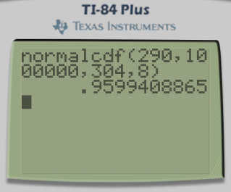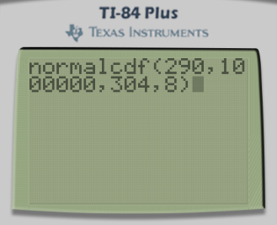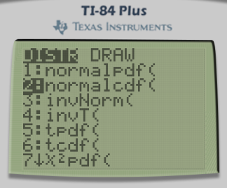

* The proportion represents the area we’re seeking.
* **Note:** If you have an updated OS (2.55), when you select normalcdf( it will prompt you to plug in:

**lower:**

**upper:**

**µ:**

**σ:**

**Normal Calculations using HP Prime:** (Using p.118 Example)

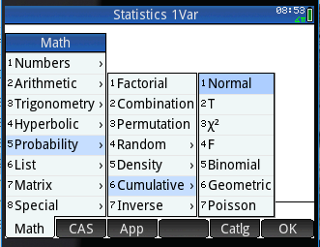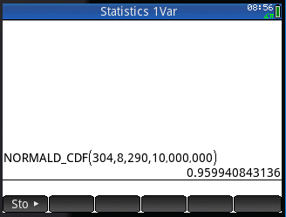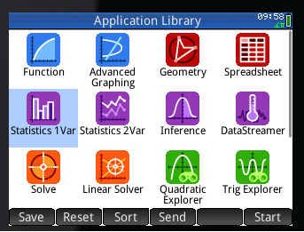



* You can trace with your finger on the screen to find your Five-number summary.
* Press Plot
* Press View
* Select Autoscale
* Enter *µ*, *σ*, lower bound, upper bound
* Press the Home Button.
* Press the ToolBox button
* Select Math, Probability, Cumulative, Normal
* Push Apps.
* Highlight or press Statistics 1 Var