**Finding Measures of Center and Spread and Plotting Boxplots using TI-series:** (Using Exercise 91, p. 70)

* Push GRAPH.
* For a better picture, press ZOOM 9:ZoomStat.
* Push ENTER.
* Make sure Plot 1 is On – Highlight On and press ENTER.
* Select the Boxplot
* Make sure your Xlist matches the list you entered your data.
* Press 2nd STAT PLOT (Y=).
* Scroll down to see the rest of the statistics
* Push STAT.
* Push ENTER.
* Enter data. (All in the L1 column.)
* Push STAT.
* Scroll left to CALC
* Select 1-Var Stats
* Push ENTER
* Note: We use Sx for Standard deviation.
* Select the Modified Box plot. Notice at the bottom it asks how you want your outliers marked.

**Finding Measures of Center and Spread and Plotting Boxplots using HP Prime:** (Using Exercise 91, p. 70)

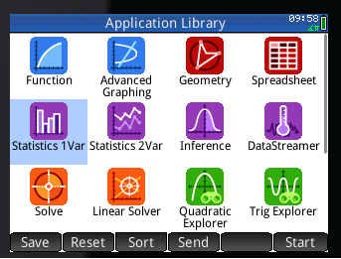



* You can trace with your finger on the screen to find your Five-number summary.
* Press Plot
* Press View
* Select Autoscale
* Press Symb
* Go to the Drop down menu and select BoxWhisker
* Push Stats in the lower right corner
* Scroll down for more statistics
* Enter data.
* Push Apps.
* Highlight or press Statistics 1 Var

**To plot a modified boxplot, select Option when you’re in Symbolic View and select “Show Outliers”.**