Constructing Histograms on the TI-83, 83-Plus, 84, or 84-Plus

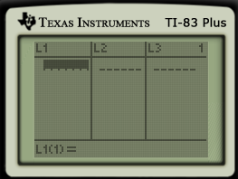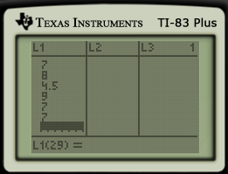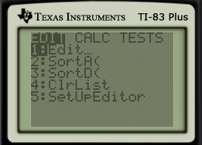

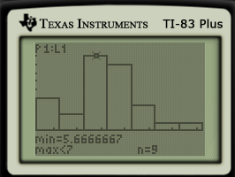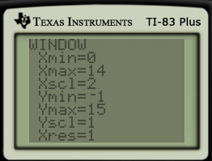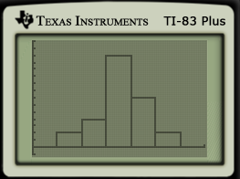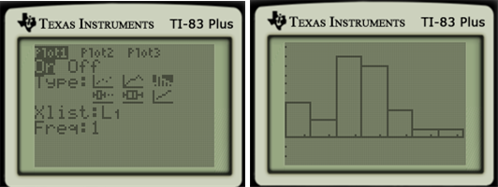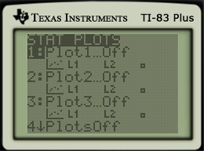

* If you want to change the class width:
  + Press WINDOW and change settings.
* Push TRACE.
* This allows you to see what the range is for each class and the number that fall in that class.
* Push ENTER.
* Make sure Plot 1 is On – Highlight On and press ENTER.
* Select the Histogram under Type.
* Make sure your Xlist matches the list you entered your data.
* Push GRAPH.
* For a better picture, press ZOOM 9: ZoomStat.
* Push 2nd and QUIT (MODE).
* Press 2nd STAT PLOT (Y=).
* Enter data. (All in the L1 column.)
* After you have entered one observation, press ENTER to go to the next line.
* Push ENTER.
* Push STAT.

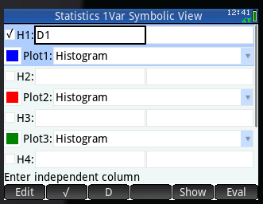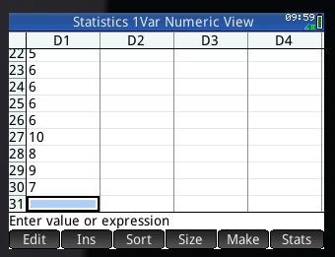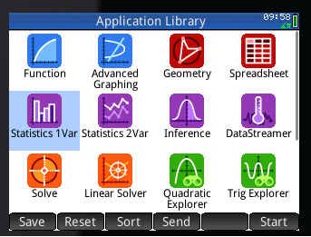Constructing Histograms on the HP Prime

* Push Apps.
* Highlight or press Statistics 1 Var
* Push Apps.
* Highlight or press Statistics 1 Var
* Press Symb
* Make sure H1 is checked
* Select Histogram under the drop down menu
* Enter data.
* Push Apps.
* Highlight or press Statistics 1 Var

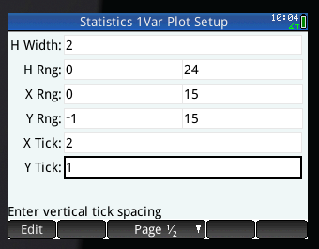

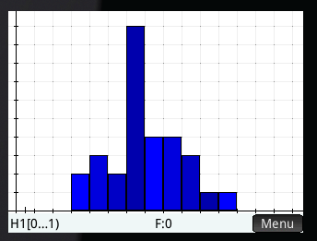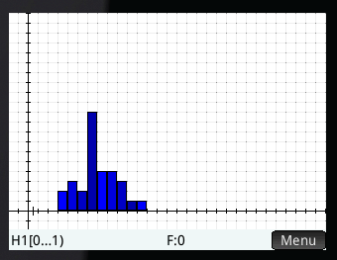

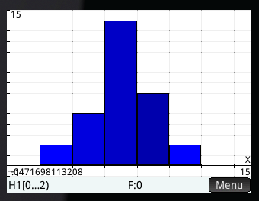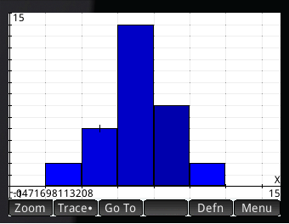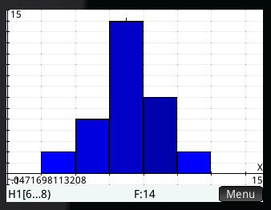

* If you want to Trace, press Menu and check to see that there is a dot beside Trace.
* Press Menu again.
* Push Plot.
* To change window, push Shift, Plot.
* To Zoom in, Press Menu
* Press Zoom
* Select 3 In
* Push Plot.