**Chapter 3: Describing Relationships CALCULATOR STEPS**

**TI-Series**

**Entering Data: Turning DiagnosticOn (for r & r2)**

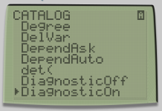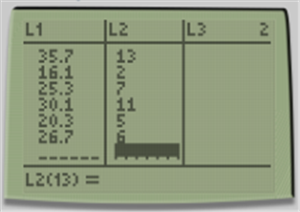

Note: if you put your data in a different list, you must indicate that you want to use that list when graphing and finding LSRL.

* + 2nd 🡪 0 (Catalog)
  + ↓ DiagnosticOn
  + Press Enter twice
* STAT PLOT 🡪 Edit
* Enter data.
  + *x-*variable in L1
  + *y-*variable in L2

**Getting the LSRL, correlation, and coefficient of determination:**

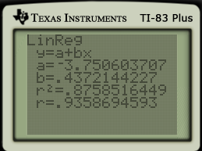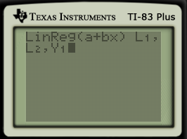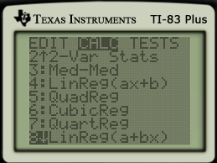

* Press Enter
* L1: 2nd, press 1
* L2: 2nd, press 2
* Y1: VARS 🡪 Y-VARS ↓

1: Function, Select 1: Y1

* STAT PLOT 🡪 CALC
* ↓ 8: LinReg(a+bx)
* Press Enter

**To graph Scatterplot:**

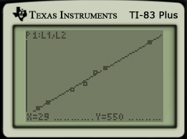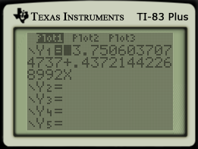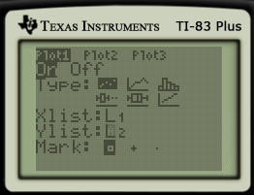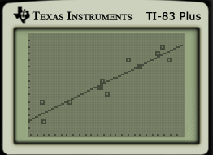

* Press Trace.
* Going ← and → will help you jump from point to point
* Going ↑ and ↓ helps you jump from the points to the line
* Zoom 9 to graph
* Press Y=
* Make sure Plot 1 is On with L1 & L2 for the x- and y-list
* 2nd 🡪 STAT PLOT
* Select Scatterplot
  + *x*-list: L1
  + *y*-list: L2

**Getting residuals:**

You have to have done all of the previous steps before you can find residuals. Make sure there is something in Y1 under Y = before you do this.

**Plotting residuals:**

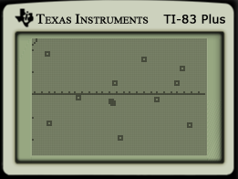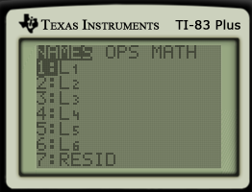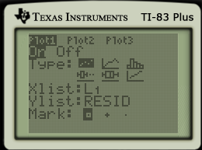

* Zoom 9 to graph
* Go to STAT PLOT
* Go to Ylist
* Press 2nd List (STAT button)
* Select 7:RESID

**Chapter 3: Describing Relationships CALCULATOR STEPS**

**HP Prime**

**Selecting the correct App: Entering Data: Finding r & r2**

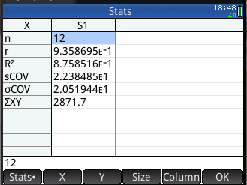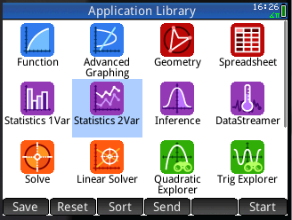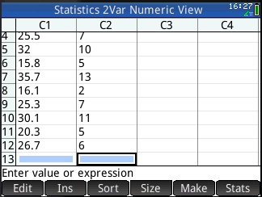

* Press Stats in lower right corner
* r ≈ 0.9359
* Apps
* Select Statistics 2 Var
* Enter data
  + *x-*variable in C1
  + *y*-variable in C2

**Getting the LSRL and plotting the Scatterplot:**

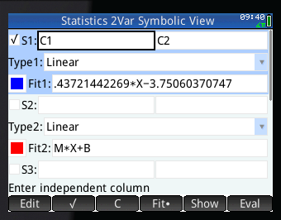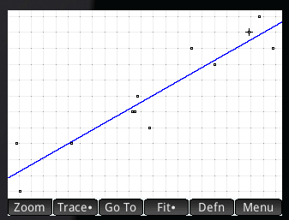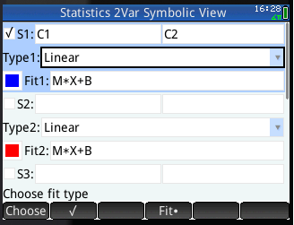

* Go back go SYMB
* Check out the equation
* Press Symb
* First box is *x-*variable (C1), Second box is *y*-variable (C2)
* Make sure it says linear
* Fit 1 should have M*X+B
* Press Plot
* Press Menu, then Fit to get the line

**To trace:**

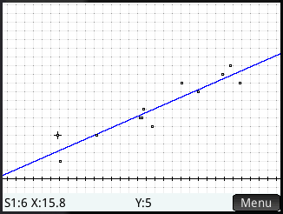

* Press Plot
* Press Menu, make sure there is a dot next to trace, press Menu again.
* Use 🡪 and 🡨 to move from point to point.
* Use ↑ and ↓ to jump between points and the line.

Note: If you put your data in a different list, you must indicate that you want to use that list when graphing and finding LSRL.

**Getting residuals:**

You have to have done all of the previous steps before you can find residuals. Make sure there is something under Fit 1 (Symbolic View) before you do this.

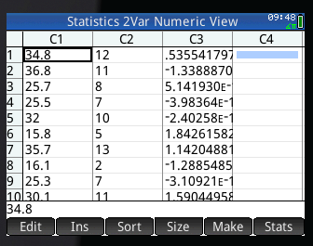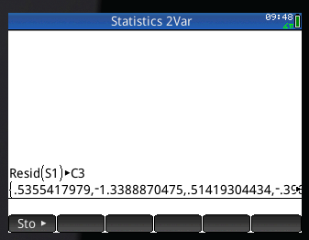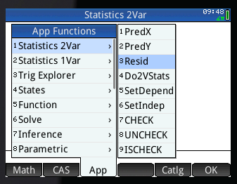

* Go to Numerical View
* Residuals are listed in C3
* Type S1 (for Scatterplot 1), Sto► (bottom right corner of screen), then C3
* Press Enter
* Go to the Home Screen
* Press the toolbox
* Select App on the screen, go ↑ to Statistics 2Var → to 3 Resid
* Press Enter

**Plotting Residuals:**

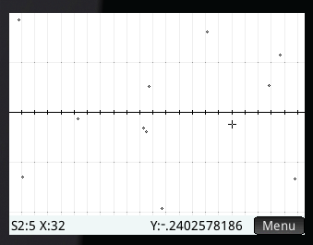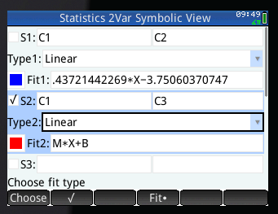

* Press Plot
* Press Menu (soft key on screen) and scroll to autoscale for better view
* Go to Symbolic View
* Uncheck S1
* Use S2 with C1 as the *x* and C3 as the *y*